Helping your child
to read and write at home

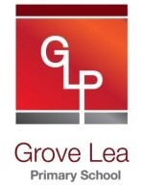

Year 1

Grove Lea Primary

At Grove Lea primary, we follow the English National Curriculum (2014).
Our school aims for reading are to:
- Provide a rich and stimulating reading environment.
- Enable children to read with confidence, accuracy, fluency, understanding and enjoyment.
- Foster an enthusiasm for and love of reading for life.
- To develop comprehension skills of inference and deduction.

Our school aims for writing are:
- For writing to be seen as purposeful and enjoyable.
- For writing to be seen as an essential life skill.
- For each child to develop the necessary writing skills to be a competent writer.
- For each child to see themselves as a confident and successful writer.
- For writing to be developed across a range of meaningful contexts.
- For there to be a broad curriculum offering the full spectrum of writing genres.

Reading

By the end of Year 1, most children should be able to…

- Match letters to all sounds
- Read accurately by blending sounds
- Read words with very common suffixes (-ing, -ed, -er)
- Read contractions (can’t, won’t I’m, let’s)
- Read books with words that can be sounded out aloud.
- Link reading to own experiences
- Join in with predictable phrases in known stories
- Discuss the title and events in a story
- Make simple predictions

Here are some suggestions of ways you can help your child at home:

• Read to and with your child every day.
• Encourage your child to read a range of texts such as newspapers, comics, poetry and non-fiction.
• Discuss your child’s reading choices with them.
• Join the local library so that your child has access to an even wider range of books
• Praise your child’s efforts and encourage them to take an interest in reading in their free time.

How many of the following high frequency words can your child read?

the |  | that |  | not |  | look |  | put
and |  | with |  | then |  | don’t |  | could
a |  | all |  | were |  | come |  | house
to |  | we |  | go |  | will |  | old
said |  | can |  | little |  | into |  | too
in |  | are |  | as |  | back |  | by
he |  | up |  | no |  | from |  | day
I |  | had |  | mum |  | children |  | made
of |  | my |  | one |  | him |  | time
it |  | her |  | them |  | Mr |  | I’m
was |  | what |  | do |  | get |  | if
you |  | there |  | me |  | just |  | help
they |  | out |  | down |  | now |  | Mrs
on |  | this |  | dad |  | came |  | called
she |  | have |  | big |  | oh |  | here
is |  | went |  | when |  | about |  | off
for |  | be |  | It’s |  | got |  | asked
at |  | like |  | see |  | their |  | saw
his |  | some |  | looked |  | people |  | make
but |  | so |  | very |  | your |  | an

Here is a list of questions that you can ask your child when reading at home:
- What happened in the story?
- What sort of books do you like?
- Do you prefer storybooks or books which help you to find out about things?
- Did you learn anything from this book?
- Is this story like any other books that you have read?
- What is this book about? How do you know?
- Can you spot any patterns in this poem?
- Can you spot words that rhyme?
- Can you think of another rhyming word which the author could have used?
- What comes next? Can you join in?
- Why did the author choose this title?
- Does the title help us to choose the right book to read?
- What happened first/next/at the end?
- Why has the author included a picture? What does it tell you?
- Did you enjoy this story? Why?
- What was your favourite part?
- Do you think this book is funny? Why?
- What is your favourite part of this story? Why?
- What do you think might happen next?
- Who do you think is telling this story?
- If (a character) does..., what do you think will happen?

Reading Recommendations for Year 1

Here at Towngate Primary Academy, we endeavour to foster a love of reading. We therefore encourage children to read for enjoyment and pleasure. Here is a list of books which are suitable for Year 4 that will help to develop a love of reading.

Title | Author
The Cat in the Hat | Dr Seuss
The Tiger Who Came to Tea | Judith Kerr
Hairy Maclary | Lynley Dodd
The Large Family Collection | Jill Murphy
Charlie and Lola | Lauren Child
The Smartest Giant in Town | Julia Donaldson
The Gruffalo’s Child | Julia Donaldson
The Gigantic Turnip | Aleksei Tolstoy
The Whisperer | Nick Butterworth
Mrs Armitage on Wheels | Quentin Blake
The Trouble with Jack | Shirley Hughes
My Friend Bear | Jez Alborough
Avocado Baby | John Burningham
A Bear Called Paddington | Michael Bond
Funnybones | Allan Ahlberg
The Hodgeheg | Dick King-Smith
The Jolly Postman | Allan Ahlberg
Mister Magnolia | Quentin Blake
Katie Morag Series | Mairi Hedderwick

Reading Comprehension Test
At the end of Key Stage 1 (end of Year 2), your child will be required to take a SATs test to test them on their reading comprehension. Here is an example of the types of questions your child may be asked in that test.

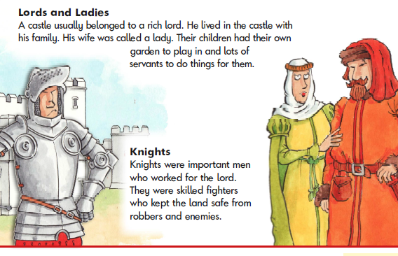

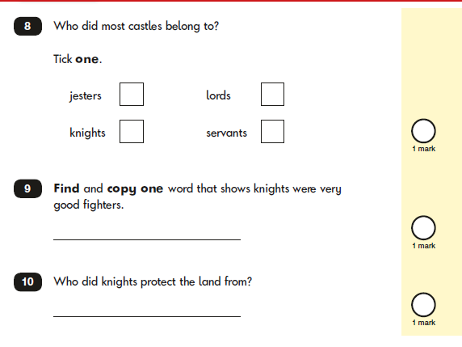

Writing

By the end of Year 1, most children should be able to…
- Name the letters of the alphabet
- Spell very common ‘exception’ words (words with unusual or uncommon spelling patterns)
- Spell the days of the week
- Use very common prefixes (-ing, -er, -ed)
- Write lower case letters correctly
- Write capital letters and numbers
- Think of and say sentences out loud before writing
- Read own writing to friends or teachers

Here are some suggestions of ways you can help your child at home:
Help your child write a letter to their favourite author. Correspondence can often be sent to an author’s publisher (whose details can be obtained on the internet) who will pass it on.
• When you go on holiday, encourage children to write postcards to friends or relatives. They could record things that you do in a holiday diary which they can share with friends or relatives when they get home.
• After making a cake or doing a craft activity, challenge children to write the recipe or instructions for someone else to use.
• Write an information page or booklet about something they find interesting e.g. spiders, Dr Who, dinosaurs, cats, etc. Draw a picture and label it or write a caption to go with it.
• Encourage your child to learn weekly spellings and phonic group spellings. Write the spellings in sentences with accurate punctuation and practise high frequency words and handwriting.
• Provide your child with a comfortable place to work and exciting writing materials. A dictionary and thesaurus would also be useful.
• Ask your child what his/her writing targets are from time to time and help them work specifically on these.
• Talk through their ideas with them before they start to write, for example, prompt them to think about how they intend to tackle a subject.
• Help them to reflect on their writing, particularly the effect they hoped to have on the reader. For example, is the reader sufficiently prepared for the ending? Have they introduced all the characters?
• Encourage them to read through their work, shaping their sentences for clarity and impact and checking their accuracy.

How many of the following high frequency words can your child spell?

Look, Say, Cover | Write and check | Look, Say, Cover | Write and check | Look, Say, Cover | Write and check
the |  | they |  | one
a |  | be |  | once
do |  | he |  | ask
to |  | me |  | friend
today |  | she |  | school
of |  | we |  | put
said |  | no |  | push
says |  | go |  | pull
are |  | so |  | full
were |  | by |  | house
was |  | my |  | our
is |  | here |  | his
has |  | there |  | where
I |  | love |  | you
come |  | your |  | some

Handwriting at Grove Lea Primary
We take pride in the presentation of our work. Children are taught to form their letters according to the following handwriting script:
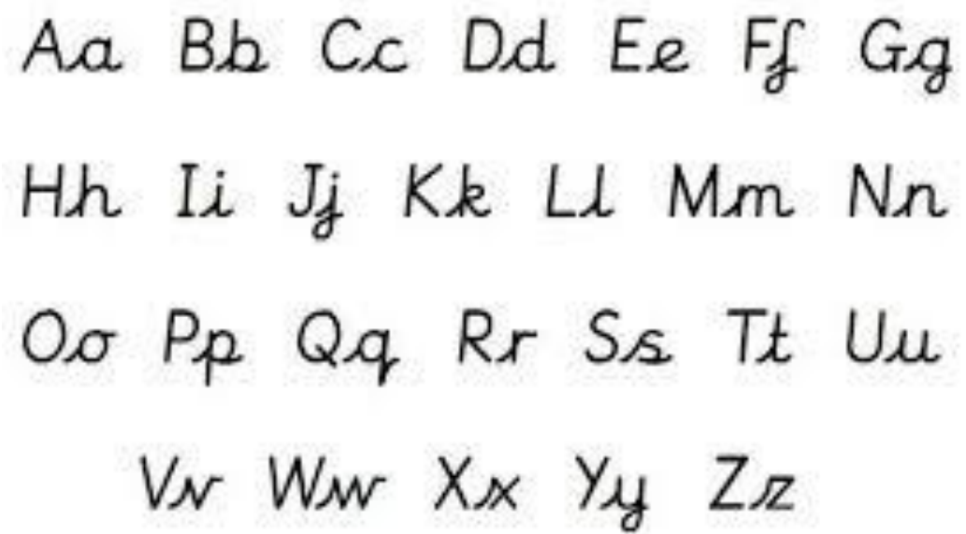

Grammarr

By the end of Year 1, most children should be able to…

- Know what nouns, verbs and adjectives are.
- Know how words can combine to make sentences.
- Join words and clauses using ‘and’
- Sequence sentences to form short narratives.
- Separate words with spaces.
- Use capital letters, full stops, question marks and exclamation marks to demarcate sentences.
- Use capital letters for names and for the personal pronoun I.

Key Words: letter, capital letter, word, singular, plural, sentence, punctuation, full stop, question mark, exclamation mark.

Here are some suggestions of ways you can help your child at home:

Expand
Talking to your child is one of this most powerful and important things you can do to develop your child’s language.
You can build up and develop sentences by asking questions.
Child: “It’s my birthday today.”
Adult: “How old are you?”
Child: “I am five.”
Adult: “It is your fifth birthday today.” … and so on…
Reconstruct

Write a sentence together. Print your writing out in big lettering including the full stop. Cut into individual words, including the full stop. Help the children to reproduce the sentence, by holding the cards in front of them. As you do more of these, collect them together and save for future use.

Please make sure your children practise using capital letters and full stops regularly.
Changing sentences:

Take a well-known sentence and change some of the words. Practice saying the sentences and then writing them down.

- Jack and Jill went up the hill. … can become…
- Fred and Kath went down the path!

Or…

- Humpty Dumpty sat on a wall; Humpty Dumpty had a great fall. …can become…
- Humpty Dumpty ran on the road; Humpty Dumpty trod on a toad!

Grammar Punctuation and Spelling Test
At the end of Key Stage 1 (End of Year 2), your child will be required to take a SATs test to test them on their understanding of the Grammar, Punctuation and Spelling curriculum. Here is an example of the types of questions your child may be asked in that test.
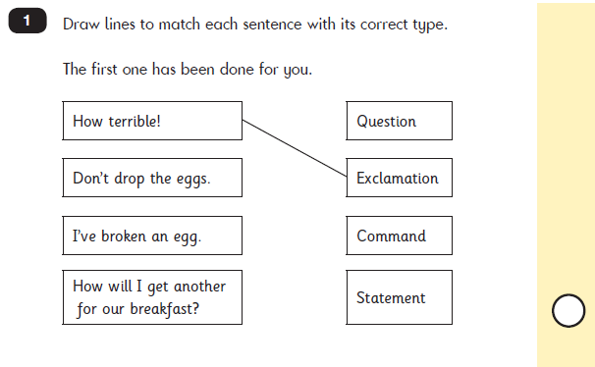

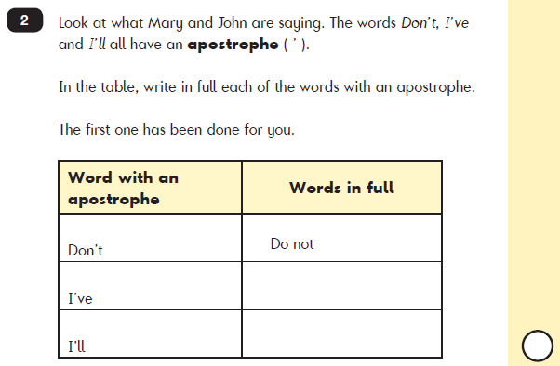

Useful websites

Reading
http://www.topmarks.co.uk/english-games/5-7-years/letters-and-sounds

http://www.bbc.co.uk/education/topics/z3882hv

http://www.ictgames.com/literacy.html

Writing
http://www.topmarks.co.uk/Interactive.aspx?cat=49

http://www.ictgames.com/literacy.html

Grammar
http://www.topmarks.co.uk/english-games/7-11-years/spelling-and-grammar
http://www.funenglishgames.com/grammargames.html
https://www.depts.ttu.edu/aged/gsp_materials/gsp_guide.pdf

Contact Us
If you require any further support or guidance with supporting your child/children with English at home, please contact your child’s class teacher or the English coordinator.

