Helping your child
to read and write at home

Year 2

Grove Lea Primary School

At Grove Lea Primary School, we follow the English National Curriculum (2014).
Our school aims for reading are to:
- Provide a rich and stimulating reading environment.
- Enable children to read with confidence, accuracy, fluency, understanding and enjoyment.
- Foster an enthusiasm for and love of reading for life.
- To develop comprehension skills of inference and deduction.

Our school aims for writing are:
- For writing to be seen as purposeful and enjoyable.
- For writing to be seen as an essential life skill.
- For each child to develop the necessary writing skills to be a competent writer.
- For each child to see themselves as a confident and successful writer.
- For writing to be developed across a range of meaningful contexts.
- For there to be a broad curriculum offering the full spectrum of writing genres.

Reading

By the end of Year 2, most children should be able to…

- Read securely by sounding out
- Read common suffixes, e.g -ing -ed -er -est -ment
-ness -ful -ly
- Read and re-read books with words they can sound out to build fluency
- Read common ‘exception’ words (words with unusual or uncommon spelling patterns)
- Discuss and express views about reading
- Retell familiar stories
- Ask and answer questions and make predictions
- Begin to make inferences (reaching a conclusion about what they have read, using clues from the text.)
- Recommend books for others to read

Here are some suggestions of ways you can help your child at home:

• Read to and with your child every day.
• Encourage your child to read a range of texts such as newspapers, comics, poetry and non-fiction.
• Discuss your child’s reading choices with them.
• Join the local library so that your child has access to an even wider range of books
• Praise your child’s efforts and encourage them to take an interest in reading in their free time.

How many of the following exception words can your child read?

door |  | even |  | sugar
floor |  | great |  | eye
poor |  | break |  | could
because |  | steak |  | should
find |  | pretty |  | would
kind |  | beautiful |  | who
mind |  | after |  | whole
behind |  | last |  | any
child |  | father |  | many
children |  | class |  | clothes
wild |  | grass |  | busy
climb |  | pass |  | people
most |  | plant |  | water
only |  | path |  | again
both old |  | bath |  | half
cold |  | hour |  | money
gold |  | move |  | Mr
hold |  | prove |  | Mrs
told |  | improve |  | parents
every |  | sure |  | Christmas
everybody |  | fast
door |  | past

Here is a list of questions that you can ask your child when reading at home:
- Can you use your sounds and blend them together to read this word?
- Can you work out what this (unfamiliar) word means by reading the words around it?
- Can you change your voice when this character speaks?
- What was your favourite part of this book?
- Can you choose a character from the story that interests you, and say why?
- Have you ever been in a similar situation? What happened? How did you feel/behave?
- What happened in the story?
- Were you surprised by the ending? Is it what you expected?
- Can you predict what you think might happen next?
- What do you think will happen to that character now?
- Why did (a character) behave in this way?
- How does the character feel at this point in the story? Can you find clues in the text and illustrations to show me why you think this?
- Is this book fiction or non-fiction? How do you know?
- What made you choose this book? What sort of book is this, and how can you tell?
- Is this book similar to any other books you have read in the past?
- Has the author put certain words in bold or in italics? Why do you think they have done this?
- Can you find the contents/index/glossary? Why does the author include these?
- Can you find any amazing adjectives?
- What adverb has been used to describe how the character ran across the field?
- Can you find a powerful verb? Why has the author chosen this verb?
- How does punctuation help you to read for sense?

Reading Recommendations for Year 2

Here at Towngate Primary Academy, we endeavour to foster a love of reading. We therefore encourage children to read for enjoyment and pleasure. Here is a list of books which are suitable for Year 4 that will help to develop a love of reading.

Title | Author
The Cat Who Lost His Purr | Michelle Coxon
Frightened Fred | Peta Coplans
Friends | Kim Lewis
Mog Stories | Judith Kerr
Mr Wolf’s Pancakes | Jan Fearnley
Frog is Frog | Max Velthuijis
Cat and Mouse Story | Michael Rosen
The Snow Lady | Shirley Hughes
Grace and Family | Mary Hoffman and Caroline Binch
The Adventures of Captain Underpants | Dav Pilkey
The Diary of a Killer Cat | Anne Fine
Little Wolf’s Book of Badness | Ian Whybrow
The Magic Finger | Roald Dahl
Mrs Wobble the Waitress | Allan Alhberg
Pirate School: Just a Bit of Wind | Jeremy Strong
George’s Marvellous Medicine | Roald Dahl
The Giraffe, Pelly and Me | Roald Dahl
The Guard Dog | Dick King-Smith
Emily’s Legs | Dick King-Smith

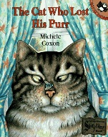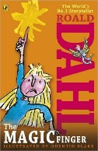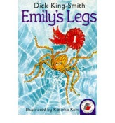

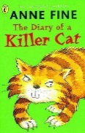

Reading Comprehension Test
At the end of Key Stage 1 (end of Year 2), your child will be required to take a SATs test to test them on their reading comprehension. Here is an example of the types of questions your child may be asked in that test.

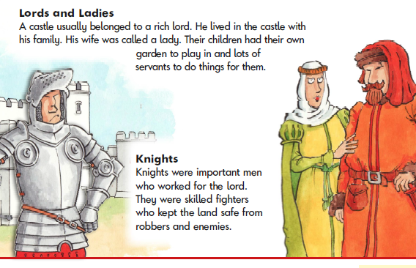

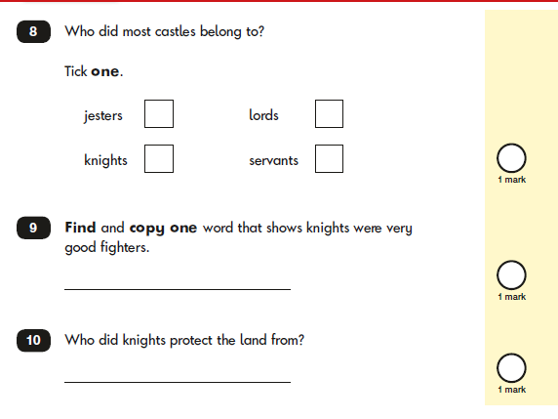

Writing

By the end of Year 2, most children should be able to…
- Spell words by sounding out
- Learn to spell common ‘exception’ words (words with unusual or uncommon spelling patterns)
- Spell using common suffixes e.g -ing -ed -er -est -ment
-ness -ful -ly
- Use appropriate size letters & spaces
- Develop positive attitude for writing and be able to write longer pieces
- Begin to plan ideas for writing
- Record ideas sentence-by-sentence
- Make simple additions & changes after proof-reading

Here are some suggestions of ways you can help your child at home:
Help your child write a letter to their favourite author. Correspondence can often be sent to an author’s publisher (whose details can be obtained on the internet) who will pass it on.
• When you go on holiday, encourage children to write postcards to friends or relatives. They could record things that you do in a holiday diary which they can share with friends or relatives when they get home.
• After making a cake or doing a craft activity, challenge children to write the recipe or instructions for someone else to use.
• Write an information page or booklet about something they find interesting e.g. spiders, Dr Who, dinosaurs, cats, etc. Draw a picture and label it or write a caption to go with it.
• Encourage your child to learn weekly spellings and phonic group spellings. Write the spellings in sentences with accurate punctuation and practise high frequency words and handwriting.
• Provide your child with a comfortable place to work and exciting writing materials. A dictionary and thesaurus would also be useful.
• Ask your child what his/her writing targets are from time to time and help them work specifically on these.
• Talk through their ideas with them before they start to write, for example, prompt them to think about how they intend to tackle a subject.
• Help them to reflect on their writing, particularly the effect they hoped to have on the reader. For example, is the reader sufficiently prepared for the ending? Have they introduced all the characters?
• Encourage them to read through their work, shaping their sentences for clarity and impact and checking their accuracy.

How many of the following exception words can your child spell?

Look, Say, Cover | Write and check | Look, Say, Cover | Write and check | Look, Say, Cover | Write and check
door |  | even |  | sugar
floor |  | great |  | eye
poor |  | break |  | could
because |  | steak |  | should
find |  | pretty |  | would
kind |  | beautiful |  | who
mind |  | after |  | whole
behind |  | last |  | any
child |  | father |  | many
children |  | class |  | clothes
wild |  | grass |  | busy
climb |  | pass |  | people
most |  | plant |  | water
only |  | path |  | again
both old |  | bath |  | half
cold |  | hour |  | money
gold |  | move |  | Mr
hold |  | prove |  | Mrs
told |  | improve |  | parents
every |  | sure |  | Christmas
everybody |  | fast
door |  | past

Handwriting at Grove Lea Primary School
We take pride in the presentation of our work. Children are taught to form their letters according to the following handwriting script:
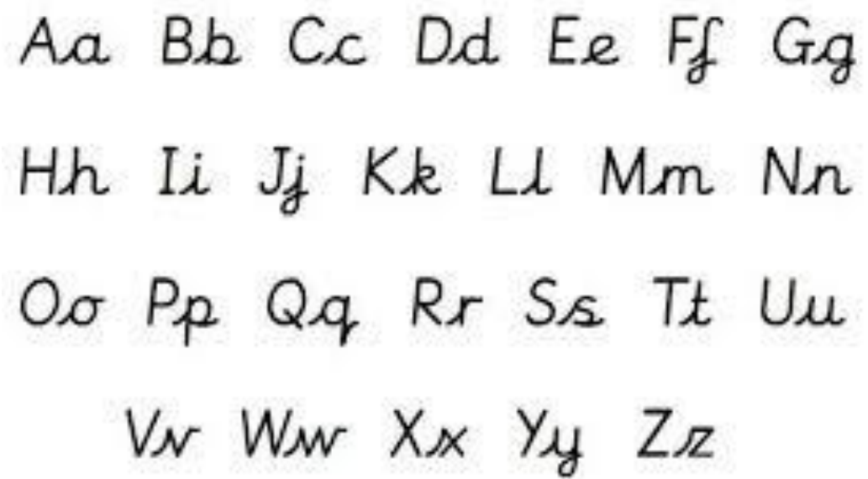

Grammar

By the end of Year 2, most children should be able to…
- Know what nouns, verbs, adjectives and adverbs are
- Use subordination – using…when, if, that, because
- Use coordination – using…or, and, but
- Know how to expand noun phrases for description and specification (e.g. the blue butterfly, plain flour, the man in the Moon.)
- Know how the grammatical patterns in a sentence indicate its function as a statement, question, exclamation or command
- Make the correct choice of present tense and past tense
- Use the progressive form of verbs in the present and past tense to mark actions in progress (e.g. she is drumming; he was shouting.)
- Use capital letters, full stops, question marks and exclamation marks to demarcate sentences and commas to separate items in a list
- Use apostrophes to mark where letters are missing in spelling and to mark singular possession in nouns (e.g. the girl’s name.)

Key Words: noun, noun phrase, statement, question, exclamation, command, compound, adjective, verb, suffix, adverb, tense (past, present), apostrophe, comma.

Here are some suggestions of ways you can help your child at home:

Punctuation spotter
Print off a piece of text from a book, magazine or
the internet. Go through this, highlighting all of the
capital letters and full stops. Make a chart to record,
“When do we use capital letters?” Do the same
with question marks, exclamation marks or verbs
and adjectives.

Perfect punctuation

Write a short piece of text with full stops in the wrong place. Read it through together. Does it sound right? Alter it by reading through and listening to hear when the sentence is complete. Correct accordingly.

Finish the sentence:

Give your child some sentence stems and conjunctions – e.g. The dog ran over the road… when, because, next, etc.

Children compose appropriate endings. Discuss. Are the endings interchangeable? Does the meaning change according to the conjunction being used?

Stretchy sentences: Can you stretch these sentences?

To make them longer you need to add more information.

e.g. The boy went to the park.

The happy, young boy went to play with his friends at the huge, exciting park.

Use conjunctions to make these sentences more interesting.
7. I can’t go swimming. I have forgotten my swimming trunks.
____________________________________________
8. I’d like to go to the park. My mum won’t let me.
____________________________________________
9. The old woman wanted to feed her dog. There was nothing in the cupboard.
____________________________________________
10. I bought some sweets. I ate them on the way home.
____________________________________________
11. The teacher was cross. She was late.

1 | The fox had a tail.
2 | The sea was calm.
3 | The bat was squeaking.
4 | We went on the slide.
5 | The hedgehog has spikes.
6 | I had an ice-cream.
7 | An owl was flying.

Grammar Punctuation and Spelling Test
At the end of Key Stage 1 (End of Year 2), your child will be required to take a SATs test to test them on their understanding of the Grammar, Punctuation and Spelling curriculum. Here is an example of the types of questions your child may be asked in that test.

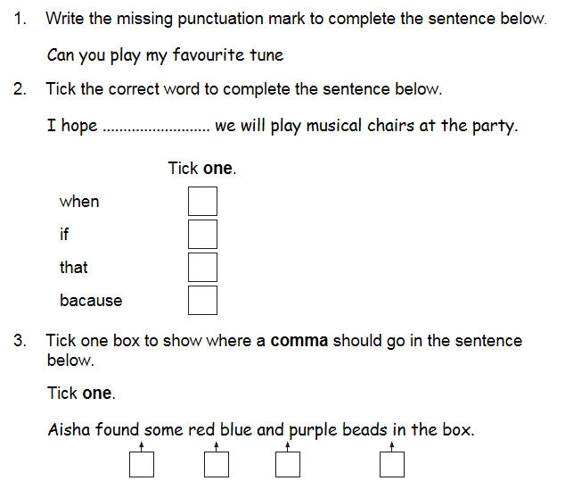
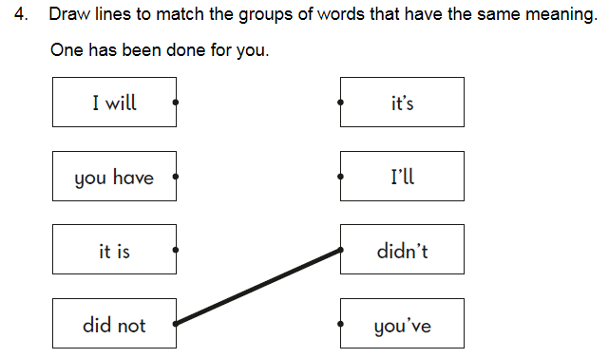
Useful websites

Useful websites

Reading
http://www.topmarks.co.uk/english-games/5-7-years/letters-and-sounds

http://www.bbc.co.uk/education/topics/z3882hv

http://www.ictgames.com/literacy.html

Writing
http://www.topmarks.co.uk/Interactive.aspx?cat=49

http://www.ictgames.com/literacy.html

Grammar
http://www.topmarks.co.uk/english-games/7-11-years/spelling-and-grammar

http://www.funenglishgames.com/grammargames.html

https://www.depts.ttu.edu/aged/gsp_materials/gsp_guide.pdf

Contact Us
If you require any further support or guidance with supporting your child/children with English at home, please contact your child’s class teacher or the English coordinator.

