Helping your child
to read and write at home

Year 3

Grove Lea Primary School
At Grove Lea Primary School, we follow the English National Curriculum (2014).
Our school aims for reading are to:
- Provide a rich and stimulating reading environment.
- Enable children to read with confidence, accuracy, fluency, understanding and enjoyment.
- Foster an enthusiasm for and love of reading for life.
- To develop comprehension skills of inference and deduction.

Our school aims for writing are:
- For writing to be seen as purposeful and enjoyable.
- For writing to be seen as an essential life skill.
- For each child to develop the necessary writing skills to be a competent writer.
- For each child to see themselves as a confident and successful writer.
- For writing to be developed across a range of meaningful contexts.
- For there to be a broad curriculum offering the full spectrum of writing genres.

Reading

By the end of Year 3, most children should be able to…
- Use what they know to read ‘exception’ words (words with unusual or uncommon spelling patterns)
- Read a range of fiction & non-fiction books
- Use dictionaries to check meaning
- Prepare poems & plays to perform
- Check their own understanding of reading
- Draw inferences (reaching a conclusion about what they have read, using clues from the text) and make predictions
- Retrieve & record information from non-fiction books
- Discuss reading with others

Here are some suggestions of ways you can help your child at home:

• Read to and with your child every day.
• Encourage your child to read a range of texts such as newspapers, comics, poetry and non-fiction.
• Discuss your child’s reading choices with them.
• Join the local library so that your child has access to an even wider range of books
• Praise your child’s efforts and encourage them to take an interest in reading in their free time.

How many of the following exception words can your child read?
accident |  | continue |  | guard |  | notice |  | recent
actual |  | decide |  | guide |  | occasion |  | regular
actually |  | describe |  | heard |  | occasionally |  | reign
address |  | different |  | heart |  | often |  | remember
answer |  | difficult |  | height |  | opposite |  | sentence
appear |  | disappear |  | history |  | ordinary |  | separate
arrive |  | early |  | imagine |  | particular |  | special
believe |  | earth |  | increase |  | peculiar |  | straight
bicycle |  | eight |  | important |  | perhaps |  | strange
breath |  | eighth |  | interest |  | popular |  | strength
breathe |  | enough |  | island |  | position |  | suppose
build |  | exercise |  | knowledge |  | possession |  | surprise
busy |  | experience |  | learn |  | possess |  | therefore
business |  | experiment |  | length |  | possible |  | though
calendar |  | extreme |  | library |  | potatoes |  | although
caught |  | famous |  | material |  | pressure |  | thought
centre |  | February |  | medicine |  | probably |  | through
century |  | forward |  | mention |  | promise |  | various
certain |  | fruit |  | minute |  | purpose |  | weight
circle |  | grammar |  | natural |  | quarter |  | woman
complete |  | group |  | naughty |  | question |  | women
consider

Here is a list of questions that you can ask your child when reading at home:
- What happened in the story?
- Where does the story take place?
- Who is telling the story?
- Where and when is this story/text set? How does the writer show this?
- How did this character respond to (an event)?
- How are the beginning and end similar? Is the order of events important?
- Which part of the story best describes the setting?
- Can you identify words in the text which help the author create mood/effect?
- What adverb has been used to describe how the character…?
- What does the word (choose a word) tell you about…?
- Which words/phrase indicates how the character was feeling?
- What is the genre of this story? How do you know?
- What features make this book similar to (another text)?
- Do these texts share any common features e.g. language or theme?
- What can you infer about this character? Can you find some words or phrases that demonstrate this in the text?
- Can you choose a character and say what they felt/thought/did in response to events? How do you know?
- What does... tell you about how the character is feeling?
- How did this character's actions affect the outcome of the story?
- Knowing what you do about (a character/an event), what might happen next? Why do you think this?
- If the story develops in the way you have predicted, how will (a character) respond? Can you find evidence in the text to explain why you think this is?
- How does the author indicate that (a character) feels excited/worried/scared? Does the author show this directly?

Reading Recommendations for Year 3

Here at Towngate Primary Academy, we endeavour to foster a love of reading. We therefore encourage children to read for enjoyment and pleasure. Here is a list of books which are suitable for Year 4 that will help to develop a love of reading.
Title | Author
It Was a Dark and Stormy Night | Janet Ahlberg
The Railway Cat | Phyllis Arkle
Cool | Michael Morpurgo
The Butterfly Lion | Michael Morpurgo
Fungus the Bogeyman | Raymond Briggs
Charlotte’s Web | E B White
The Twits | Roald Dahl
Charlie and Chocolate Factory | Roald Dahl
Matilda | Roald Dahl
The Indian in the Cupboard | Lynne Reid Banks
Mystery Winklesea | Helen Cresswell
Fantastic Mr Fox | Roald Dahl
Flat Stanley | Jeff Brown
The Sheep Pig | Dick King-Smith
Bill’s New Frock | Anne Fine
The Hundred Mile an Hour Dog | Jeremy Strong
Return of the Hundred Mile an Hour Dog | Jeremy Strong
The Naughtiest Girl in the School | Enid Blyton
Secret Seven series | Enid Blyton

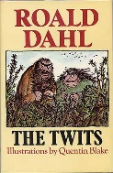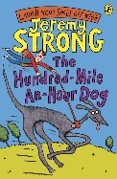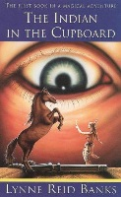

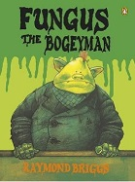

Reading Comprehension Test
At the end of Key Stage 2 (end of Year 6), your child will be required to take a SATs test to test them on their reading comprehension. Here is an example of the types of questions your child may be asked in that test.
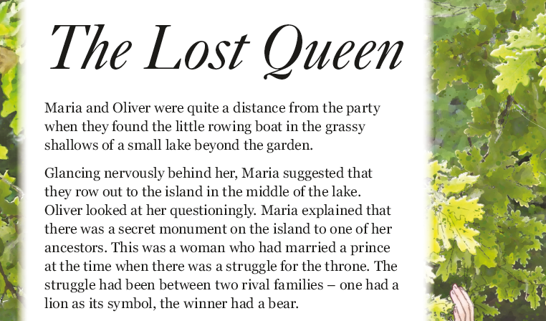
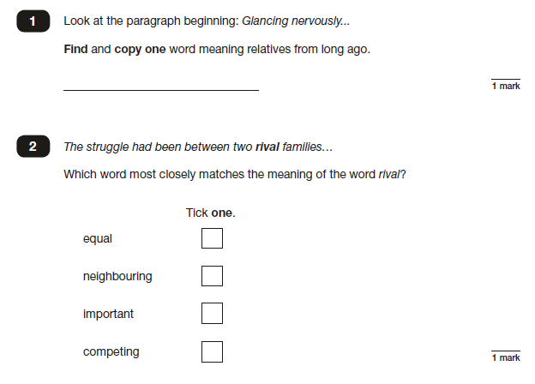

Writing

By the end of Year 3, most children should be able to…
- Use prefixes & suffixes in spelling – e.g. in-, dis-, mis-,
-ation, -ly
- Use dictionary to confirm spellings
- Write simple dictated sentences
- Use handwriting joins correctly
- Plan to write based on familiar forms
- Rehearse sentences out loud before writing
- Use varied rich vocabulary
- Create simple settings & plot
- Assess effectiveness of own and others’ writing

Here are some suggestions of ways you can help your child at home:
• Help your child write a letter to their favourite author. Correspondence can often be sent to an author’s publisher (whose details can be obtained on the internet) who will pass it on.
• When you go on holiday, encourage children to write postcards to friends or relatives. They could record things that you do in a holiday diary which they can share with friends or relatives when they get home.
• After making a cake or doing a craft activity, challenge children to write the recipe or instructions for someone else to use.
• Write an information page or booklet about something they find interesting e.g. spiders, Dr Who, dinosaurs, cats, etc. Draw a picture and label it or write a caption to go with it.
• Encourage your child to learn weekly spellings and phonic group spellings. Write the spellings in sentences with accurate punctuation and practise high frequency words and handwriting.
• Provide your child with a comfortable place to work and exciting writing materials. A dictionary and thesaurus would also be useful.
• Ask your child what his/her writing targets are from time to time and help them work specifically on these.
• Talk through their ideas with them before they start to write, for example, prompt them to think about how they intend to tackle a subject.
• Help them to reflect on their writing, particularly the effect they hoped to have on the reader. For example, is the reader sufficiently prepared for the ending? Have they introduced all the characters?
• Encourage them to read through their work, shaping their sentences for clarity and impact and checking their accuracy.

How many of the following exception words can your child spell?

Look, Say, Cover | Write and check | Look, Say, Cover | Write and check | Look, Say, Cover | Write and check | Look, Say, Cover | Write and check
accident |  | continue |  | guard |  | notice
actual |  | decide |  | guide |  | occasion
actually |  | describe |  | heard |  | occasionally
address |  | different |  | heart |  | often
answer |  | difficult |  | height |  | opposite
appear |  | disappear |  | history |  | ordinary
arrive |  | early |  | imagine |  | particular
believe |  | earth |  | increase |  | peculiar
bicycle |  | eight |  | important |  | perhaps
breath |  | eighth |  | interest |  | popular
breathe |  | enough |  | island |  | position
build |  | exercise |  | knowledge |  | possession
busy |  | experience |  | learn |  | possess
business |  | experiment |  | length |  | possible
calendar |  | extreme |  | library |  | potatoes
caught |  | famous |  | material |  | pressure
centre |  | February |  | medicine |  | probably
century |  | forward |  | mention |  | promise
certain |  | fruit |  | minute |  | purpose
circle |  | grammar |  | natural |  | quarter
complete |  | group |  | naughty |  | question
consider |  | recent |  | regular |  | reign
remember |  | sentence |  | separate |  | special
straight |  | strange |  | strength |  | suppose
surprise |  | therefore |  | though |  | although
thought |  | through |  | various |  | weight
woman |  | women

Handwriting at Grove Lea Primary
We take pride in the presentation of our work. Children are taught to form their letters according to the following handwriting script:
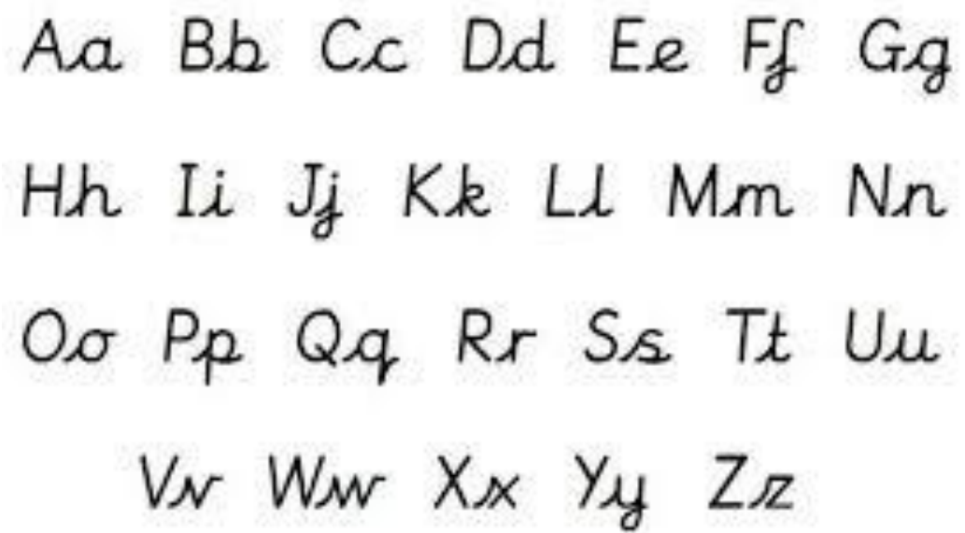

Grammar

By the end of Year 3, most children should be able to…
- Express time, place and cause using conjunctions – (e.g. when, before, after, while, so, because), adverbs (e.g. then, next, soon, therefore), or prepositions (e.g. before, after, during, in, because of)
- Know the basics of using paragraphs as a way of grouping related material
- Use headings and sub headings to aid presentation
- Use the present perfect form of verbs instead of the simple past (e.g. He has gone out to play. contrasted with… He went out to play.)
- Use inverted commas to punctuate direct speech

Key Words: adverb, preposition, conjunction, word family, prefix, clause,
direct speech, consonant, vowel, inverted commas (or ‘speech marks’).

Here are some suggestions of ways you can help your child at home:
Punctuation Police
Look at a selection of magazines, advertisements, newspapers or leaflets. Highlight the punctuation marks you can see.
- How many of each type can you see?
- Why are they there?
- Can you think of a rule?
- Can you find any exclamation marks? Why are they where they are?
- What emotion are they showing – surprise, anger, fear or anything else?

Use conjunctions to make these sentences more interesting.
7. I can’t go swimming. I have forgotten my swimming trunks.
____________________________________________
8. I’d like to go to the park. My mum won’t let me.
____________________________________________
9. The old woman wanted to feed her dog. There was nothing in the cupboard.
____________________________________________
10. I bought some sweets. I ate them on the way home.
____________________________________________
11. The teacher was cross. She was late.

Read! Read! Read!

Take a page of writing (fiction or non-fiction). Put it under the microscope.
- How many sentences are there?
- What type of sentences can you see?
- What sort of sentence does the author use first
- How does that make you feel?
- What is the page about?
- What types of words are used?
Can you spot the conjunctions in these sentences? Underline them:

1. I put on my shoes and I went out to play.
2. I can’t eat my sweets until after dinner.
3. I can’t go out tonight because I have to stay in and do my homework.
4. It had been a long time since I had last played football.
5. I was going to eat the sweets but I saved them for my sister.
6. She was nice to me although she wouldn’t let me play with the lego.

Grammar Punctuation and Spelling Test
At the end of Key Stage 2 (End of Year 6), your child will be required to take a SATs test to test them on their understanding of the Grammar, Punctuation and Spelling curriculum. Here is an example of the types of questions your child may be asked in that test.

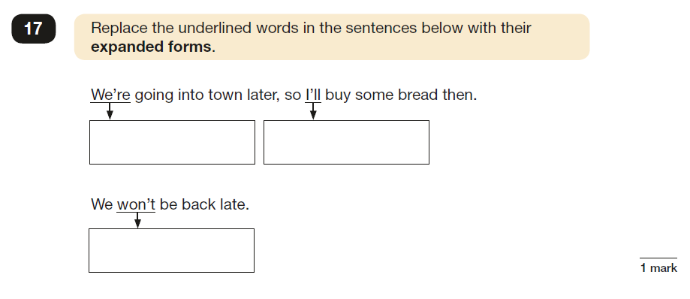
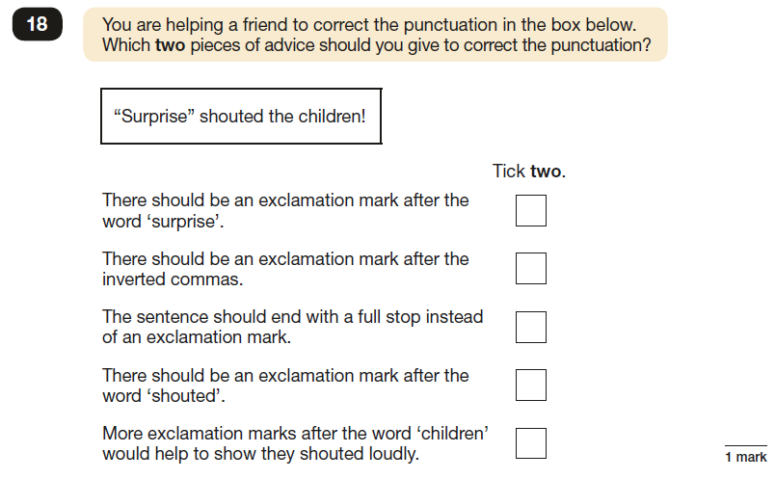

Useful websites
Reading
http://www.topmarks.co.uk/english-games/7-11-years/reading

Writing
http://www.topmarks.co.uk/english-games/7-11-years/writing
http://www.funenglishgames.com/writinggames.htm

Grammar
http://www.oswego.org/ocsd-web/match/matchgeneric.asp?filename=jwildecontractions

http://www.topmarks.co.uk/Flash.aspx?e=spelling-grammar03

http://www.sheppardsoftware.com/grammar/punctuation.htm

http://www.crickweb.co.uk/ks2literacy.html

Contact Us
If you require any further support or guidance with supporting your child/children with English at home, please contact your child’s class teacher or the English coordinator.

