Helping your child
to read and write at home

Year 4

Grove Lea Primary
At Grove Lea Primary, we follow the English National Curriculum (2014).
Our school aims for writing are:
- For writing to be seen as purposeful and enjoyable.
- For writing to be seen as an essential life skill.
- For each child to develop the necessary writing skills to be a competent writer.
- For each child to see themselves as a confident and successful writer.
- For writing to be developed across a range of meaningful contexts.
- For there to be a broad curriculum offering the full spectrum of writing genres.

Our school aims for reading are to:
- Provide a rich and stimulating reading environment.
- Enable children to read with confidence, accuracy, fluency, understanding and enjoyment.
- Foster an enthusiasm for and love of reading for life.
- To develop comprehension skills of inference and deduction.

Reading

By the end of Year 4, most children should be able to…
- Secure decoding of unfamiliar words.
- Read for a range of purposes.
- Retell some stories orally.
- Discuss words & phrases that capture the imagination.
- Identify themes & conventions.
- Retrieve & record information.
- Make inferences & justify predictions.
- Recognise a variety of forms of poetry.
- Identify & summarise ideas.

Here are some suggestions of ways you can help your child at home:

• Read to and with your child every day.
• Encourage your child to read a range of texts such as newspapers, comics, poetry and non-fiction.
• Discuss your child’s reading choices with them.
• Join the local library so that your child has access to an even wider range of books
• Praise your child’s efforts and encourage them to take an interest in reading in their free time.

How many of the following exception words can your child read?
accident |  | continue |  | guard |  | notice |  | recent
actual |  | decide |  | guide |  | occasion |  | regular
actually |  | describe |  | heard |  | occasionally |  | reign
address |  | different |  | heart |  | often |  | remember
answer |  | difficult |  | height |  | opposite |  | sentence
appear |  | disappear |  | history |  | ordinary |  | separate
arrive |  | early |  | imagine |  | particular |  | special
believe |  | earth |  | increase |  | peculiar |  | straight
bicycle |  | eight |  | important |  | perhaps |  | strange
breath |  | eighth |  | interest |  | popular |  | strength
breathe |  | enough |  | island |  | position |  | suppose
build |  | exercise |  | knowledge |  | possession |  | surprise
busy |  | experience |  | learn |  | possess |  | therefore
business |  | experiment |  | length |  | possible |  | though
calendar |  | extreme |  | library |  | potatoes |  | although
caught |  | famous |  | material |  | pressure |  | thought
centre |  | February |  | medicine |  | probably |  | through
century |  | forward |  | mention |  | promise |  | various
certain |  | fruit |  | minute |  | purpose |  | weight
circle |  | grammar |  | natural |  | quarter |  | woman
complete |  | group |  | naughty |  | question |  | women
consider

Here is a list of questions that you can ask your child when reading at home:
- What happened in the story?
- Where does the story take place?
- Who is telling the story?
- Where and when is this story/text set? How does the writer show this?
- How did this character respond to (an event)?
- How are the beginning and end similar? Is the order of events important?
- Which part of the story best describes the setting?
- Can you identify words in the text which help the author create mood/effect?
- What adverb has been used to describe how the character…?
- What does the word (choose a word) tell you about…?
- Which words/phrase indicates how the character was feeling?
- What is the genre of this story? How do you know?
- What features make this book similar to (another text)?
- Do these texts share any common features e.g. language or theme?
- What can you infer about this character? Can you find some words or phrases that demonstrate this in the text?
- Can you choose a character and say what they felt/thought/did in response to events? How do you know?
- What does... tell you about how the character is feeling?
- How did this character's actions affect the outcome of the story?
- Knowing what you do about (a character/an event), what might happen next? Why do you think this?
- If the story develops in the way you have predicted, how will (a character) respond? Can you find evidence in the text to explain why you think this is?
- How does the author indicate that (a character) feels excited/worried/scared? Does the author show this directly?

Reading Recommendations for Year 4

Here at Towngate Primary Academy, we endeavour to foster a love of reading. We therefore encourage children to read for enjoyment and pleasure. Here is a list of books which are suitable for Year 4 that will help to develop a love of reading.

Title | Author
A Caribbean Dozen | John Agard & Grace Nicholls
Alice’s Adventures in Wonderland | Lewis Carroll
Mufaro’s Beautiful Daughters | John Steptoe
Beowolf | Kevin Crossley-Holland
The Firework-Maker's Daughter | Philip Pullman
The Dragon's Child | Jenny Nimmo
The Ghost Blades | Anthony Masters
Sara, Plain and Tall | Patricia MacLachlan
Smart Girls | Robert Leeson
Brother Eagle, Sister Sky | Susan Jeffers & Chief Seattle
Robi Dobi | Madhur Jaffrey
The Reluctant Dragon | Kenneth Grahame
Flow | Pippa Goodhart
Dragon Poems | John Foster & Korky Paul
The Crazy Shoe Shuffle | Gillian Cross
The Sea Piper | Helen Cresswell
The Chocolate Touch | Patrick Skene Catling
Spacebaby | Henrietta Branford
Gregory Cool | Caroline Binch

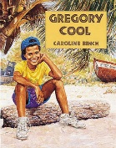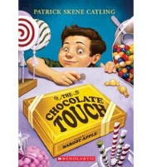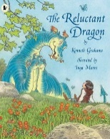

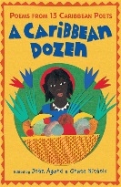

Reading Comprehension Test
At the end of Key Stage 2 (end of Year 6), your child will be required to take a SATs test to test them on their reading comprehension. Here is an example of the types of questions your child may be asked in that test.
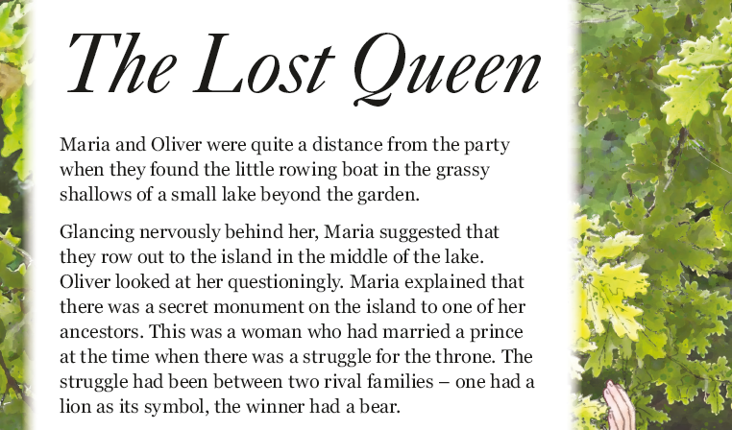
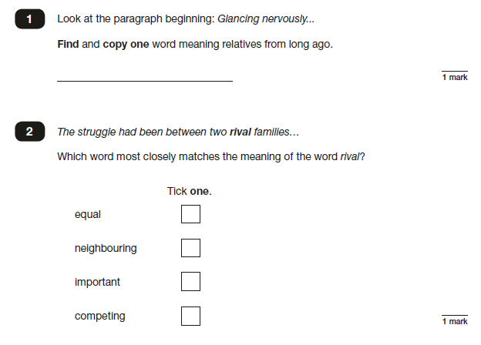

Writing

By the end of Year 4, most children should be able to…

- Correctly spell common homophones.
- Increase regularity of handwriting.
- Plan writing based on familiar forms.
- Organise writing into paragraphs.
- Use simple organisational devices.
- Proof-read for spelling & punctuation errors.
- Evaluate own and others’ writing.
- Read own writing aloud.

Here are some suggestions of ways you can help your child at home:
• Help your child write a letter to their favourite author. Correspondence can often be sent to an author’s publisher (whose details can be obtained on the internet) who will pass it on.
• When you go on holiday, encourage children to write postcards to friends or relatives. They could record things that you do in a holiday diary which they can share with friends or relatives when they get home.
• After making a cake or doing a craft activity, challenge children to write the recipe or instructions for someone else to use.
• Write an information page or booklet about something they find interesting e.g. spiders, Dr Who, dinosaurs, cats, etc. Draw a picture and label it or write a caption to go with it.
• Encourage your child to learn weekly spellings and phonic group spellings. Write the spellings in sentences with accurate punctuation and practise high frequency words and handwriting.
• Provide your child with a comfortable place to work and exciting writing materials. A dictionary and thesaurus would also be useful.
• Ask your child what his/her writing targets are from time to time and help them work specifically on these.
• Talk through their ideas with them before they start to write, for example, prompt them to think about how they intend to tackle a subject.
• Help them to reflect on their writing, particularly the effect they hoped to have on the reader. For example, is the reader sufficiently prepared for the ending? Have they introduced all the characters?
• Encourage them to read through their work, shaping their sentences for clarity and impact and checking their accuracy.

How many of the following exception words can your child spell?

Look, Say, Cover | Write and check | Look, Say, Cover | Write and check | Look, Say, Cover | Write and check | Look, Say, Cover | Write and check
accident |  | continue |  | guard |  | notice
actual |  | decide |  | guide |  | occasion
actually |  | describe |  | heard |  | occasionally
address |  | different |  | heart |  | often
answer |  | difficult |  | height |  | opposite
appear |  | disappear |  | history |  | ordinary
arrive |  | early |  | imagine |  | particular
believe |  | earth |  | increase |  | peculiar
bicycle |  | eight |  | important |  | perhaps
breath |  | eighth |  | interest |  | popular
breathe |  | enough |  | island |  | position
build |  | exercise |  | knowledge |  | possession
busy |  | experience |  | learn |  | possess
business |  | experiment |  | length |  | possible
calendar |  | extreme |  | library |  | potatoes
caught |  | famous |  | material |  | pressure
centre |  | February |  | medicine |  | probably
century |  | forward |  | mention |  | promise
certain |  | fruit |  | minute |  | purpose
circle |  | grammar |  | natural |  | quarter
complete |  | group |  | naughty |  | question
consider |  | recent |  | regular |  | reign
remember |  | sentence |  | separate |  | special
straight |  | strange |  | strength |  | suppose
surprise |  | therefore |  | though |  | although
thought |  | through |  | various |  | weight
woman |  | women

Handwriting at Grove Lea Primary
We take pride in the presentation of our work. Children are taught to form their letters according to the following handwriting script:
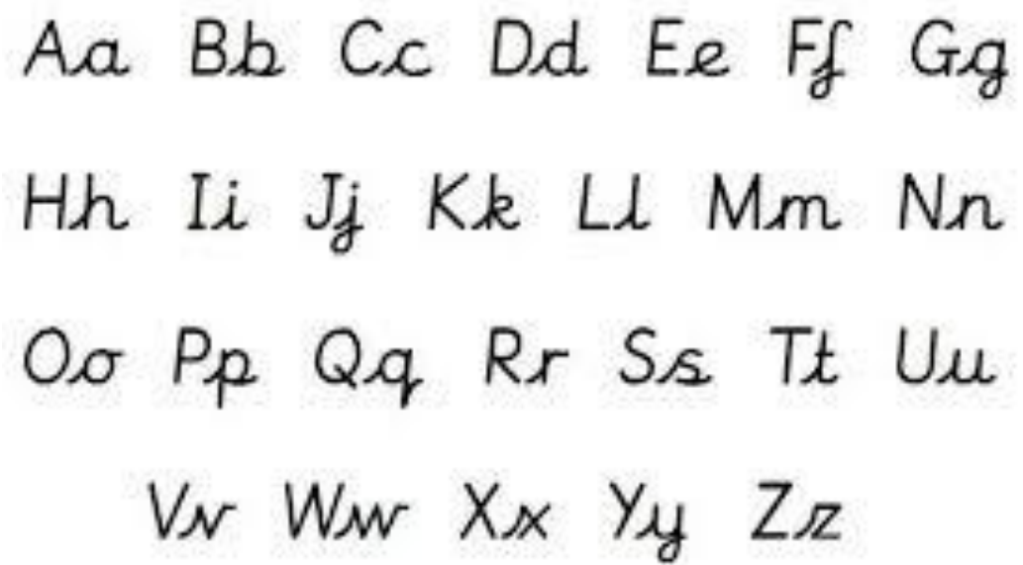

Grammar

By the end of Year 4, most children should be able to…
Key Words: determiner, pronoun, possessive pronoun, adverbial
- Expand noun phrases by the addition of modifying adjectives, nouns and preposition phrases (e.g. the teacher expanded to the strict teacher with curly red hair)
- Use fronted adverbials (e.g. Later that day, I heard the bad news).
- Use of commas after fronted adverbials.
- Use paragraphs to organise ideas around a theme.
- Choose the correct pronoun or noun within and across sentences to aid cohesion and avoid repetition.
- Use inverted commas and other punctuation to indicate direct speech (e.g. a comma after the reporting clause; end punctuation within inverted commas: The conductor shouted, “Sit down!”).
- Use apostrophes to mark singular and plural possession (e.g. the girl’s name, the girls’ names) and commas to punctuate direct speech.

Here are some suggestions of ways you can help your child at home:
Poetry please…
Work together to write fantastic descriptive poetry…
Select a topic … the sea.
Player 1 - thinks of three adjectives to describe the sea – raging, crashing, sparkling… write them on pieces of card.
Player 2 – collects three more words – encourage use of thesaurus (online or otherwise)
Carry on taking it in turns to collect words and record on card.
When you have enough – arrange and rearrange them to build your poems.
Try this with other topics.
Make as many as you can… root words
The challenge is to find as many words as you can from one root …e.g. wind – windy, windier, windfall, windpipe, windscreen, window etc.
rain…
heavy…
happy… and so on and so on.

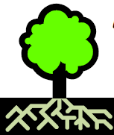

Grammar Punctuation and Spelling Test
At the end of Key Stage 2 (End of Year 6), your child will be required to take a SATs test to test them on their understanding of the Grammar, Punctuation and Spelling curriculum. Here is an example of the types of questions your child may be asked in that test.

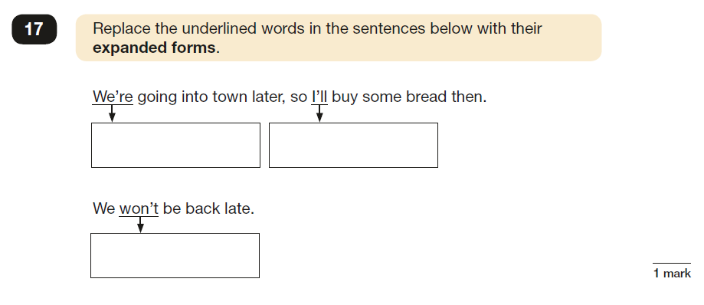
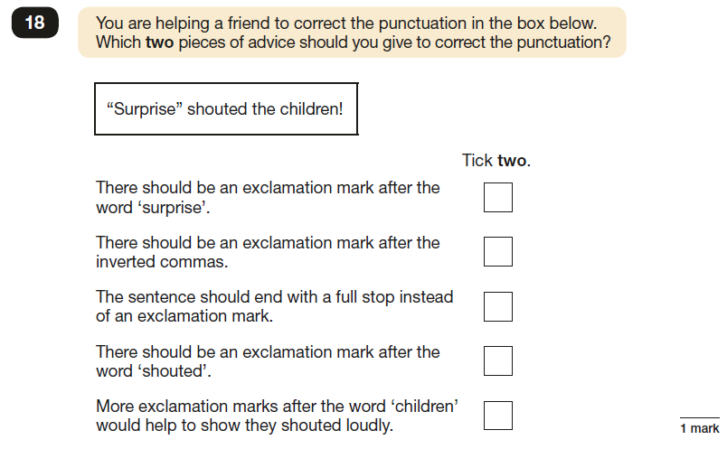

Useful websites
Reading
http://www.topmarks.co.uk/english-games/7-11-years/reading

Writing
http://www.topmarks.co.uk/english-games/7-11-years/writing
http://www.funenglishgames.com/writinggames.htm

Grammar
http://www.oswego.org/ocsd-web/match/matchgeneric.asp?filename=jwildecontractions

http://www.topmarks.co.uk/Flash.aspx?e=spelling-grammar03

http://www.sheppardsoftware.com/grammar/punctuation.htm

http://www.crickweb.co.uk/ks2literacy.html

Contact Us
If you require any further support or guidance with supporting your child/children with English at home, please contact your child’s class teacher or the English coordinator.

