Helping your child

to read and write at home



**Year 5**

Grove Lea Primary

Our Academy aims for reading are to:

* Provide a rich and stimulating reading environment.
* Enable children to read with confidence, accuracy, fluency, understanding and enjoyment.
* Foster an enthusiasm for and love of reading for life.
* To develop comprehension skills of inference and deduction.

Our school aims for writing are:

* For writing to be seen as purposeful and enjoyable.
* For writing to be seen as an essential life skill.
* For each child to develop the necessary writing skills to be a competent writer.
* For each child to see themselves as a confident and successful writer.
* For writing to be developed across a range of meaningful contexts.
* For there to be a broad curriculum offering the full spectrum of writing genres.

By the end of Year 5, children should be able to:

* Read and discuss a broad range of genres and texts
* Identify and discuss themes in a story
* Recommend books to others
* Learn poetry by heart
* Draw inference (reaching a conclusion about what they have read, using clues from the text) and make predictions
* Discuss authors’ choice of words
* Find and present information from non-fiction texts.
* Take part in formal presentations and debates.

**Here are some suggestions of ways you can help your child at home:**

• Read to and with your child every day.

• Encourage your child to read a range of texts such as newspapers, comics, poetry and non-fiction.

• Discuss your child’s reading choices with them.

• Join the local library so that your child has access to an even wider range of books

• Praise your child’s efforts and encourage them to take an interest in reading in their free time.

**How many of the following Year 5 and 6 words can your child read?**

|  |  |  |  |  |  |
| --- | --- | --- | --- | --- | --- |
| accommodate |  | curiosity |  | interrupt |  |
| accompany |  | definite |  | language |  |
| according |  | desperate |  | leisure |  |
| achieve |  | determined |  | lightning |  |
| aggressive |  | develop |  | marvellous |  |
| amateur |  | dictionary |  | mischievous |  |
| ancient |  | disastrous |  | muscle |  |
| apparent |  | embarrass |  | rhythm |  |
| appreciate |  | environment |  | sacrifice |  |
| attached |  | equipment |  | secretary |  |
| available |  | especially |  | shoulder |  |
| average |  | exaggerate |  | signature |  |
| awkward |  | excellent |  | sincere(ly) |  |
| bargain |  | existence |  | stomach |  |
| bruise |  | explanation |  | sufficient |  |
| category |  | familiar |  | suggest |  |
| cemetery |  | foreign |  | symbol |  |
| committee |  | forty |  | system |  |
| communicate |  | frequently |  | temperature |  |
| community |  | government |  | thorough |  |
| competition |  | guarantee |  | twelfth |  |
| conscience |  | harass |  | variety |  |
| conscious |  | hindrance |  | vegetable |  |
| controversy |  | identity |  | vehicle |  |
| convenience |  | Immediate/ly |  | yacht |  |
| correspond |  | individual |  |  |  |
| criticise |  | interfere |  |  |  |

**Here is a list of questions that you can ask your child when reading**

* Find an unfamiliar technical word. Think about how it is used in this sentence. What do you think it means?
* How does the front cover show that this book is one in a series?
* Have you been in a similar situation to the character in this book?
* Who would you like to meet in the story? Why?
* What is the theme of this book? How does the author create a sense of loss/heroism etc.?
* Why does the author use the first person in this diary/autobiography?
* Where/when, is this story/poem set? Does this make a difference to how we read it?
* Which do you prefer; texts set in historical times or in modern times? Why?
* Can you make a list of features in this text type? Does the author use these features in the way you would expect?
* Have you read any other stories, which handle time in this way e.g. flashbacks, dreams?
* Who is this book aimed at? Do you think it is successful for this audience?
* What made you choose this book?
* Whom would you recommend this book to? Why?
* Can you find examples of simile/metaphor/alliteration/personification in this poem?
* Which words or phrases particularly stick in your mind? Why?
* What do you think is going to happen to the main character and how will they feel about this? What makes you think this?
* Why did (a character) behave in this way? Knowing what you know now, what do you think they were hoping to achieve?
* Use of language
* How does the title engage the reader?
* Give examples of words chosen by the author to describe (a character)? Are they effective?
* Can you list words and phrases which show you how the speaker is feeling?
* Can you find a descriptive phrase and consider the effect it has on the reader? Which words create this effect?
* What does... mean? Could you use a more emotive word? What about a less emotive word?
* Do the events happen in time order? If not, why not?
* Retrieve and present information from non-fiction
* What specific information do you need to retrieve from this text?
* Where would you look for information on...?
* How could you use the contents/index/glossary to help?
* Does the structure of the book help you to understand the subject?
* How is the information organised and presented? Why do you think this order/these headings were chosen?

**Reading Recommendations for Year 5**

Here at Towngate Primary Academy, we endeavour to foster a love of reading. We therefore encourage children to read for enjoyment and pleasure. Here is a list of books, which are suitable for Year 5 that will help to develop a love of reading.

|  |  |
| --- | --- |
| **Title** | **Author** |
| The Peppermint Pig | Nina Bawden |
| War Dog | Martin Booth |
| Eric the Viking | Terry Jones |
| The Capricorn Bracelet | Rosemary Sutcliff |
| The Cartoonist | Betsy Byars |
| Boy Overboard | Maurice Gleitzman |
| The Ordinary Princess | M.M. Kaye |
| My Family and Other Disasters | Lucy Mangan |
| Madame Doubtfire | Anne Fine |
| The Future Telling Lady | James Berry |
| The Daydreamer | Ian McEwan |
| Dragon Rider | Cornilia Funke |
| Dogsbody | Diane Wynne Jones |
| The Iron Women | Ted Hughes |
| The Borrowers | Mary Norton |
| Stormbreaker | Anthony Horowitz |
| How to Live Forever | Colin Thompson |

[](http://www.google.co.uk/url?sa=i&rct=j&q=&esrc=s&source=images&cd=&cad=rja&uact=8&ved=0ahUKEwjK1p2R1_DNAhWCJ8AKHTjTCP4QjRwIBw&url=http://thatwasnotinthebook.com/diff/madame_doubtfire_book_1987_vs_mrs._doubtfire_movie_1993&psig=AFQjCNFfobnbJ1hL4SQMRH0u--HdMEgEKQ&ust=1468507564902488) [](https://www.google.co.uk/url?sa=i&rct=j&q=&esrc=s&source=images&cd=&cad=rja&uact=8&ved=0ahUKEwiirfyl1_DNAhVEBMAKHfNHAJ4QjRwIBw&url=https://en.wikipedia.org/wiki/Stormbreaker&bvm=bv.126993452,d.ZGg&psig=AFQjCNFTEM2tQn6YEaSkTAz1kB2neTShAg&ust=1468507610299827) [](http://www.google.co.uk/url?sa=i&rct=j&q=&esrc=s&source=images&cd=&cad=rja&uact=8&ved=0ahUKEwjf-pXC1_DNAhXnIMAKHTxXDoAQjRwIBw&url=http://www.abebooks.co.uk/9780241131275/Future-telling-Lady-Berry-James-0241131278/plp&bvm=bv.126993452,d.ZGg&psig=AFQjCNFJYfKVgxKP3thTiyDygJtEY8HYsw&ust=1468507667148651) [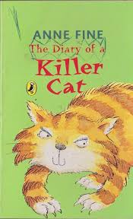](http://www.google.co.uk/url?sa=i&rct=j&q=&esrc=s&frm=1&source=images&cd=&cad=rja&uact=8&ved=0ahUKEwjsiKf9odzNAhXGC8AKHS1IBz8QjRwIBw&url=http://www.thebookshop.ie/fine-anne--the-diary-of-a-killer-cat-27505-p.asp&bvm=bv.126130881,d.ZGg&psig=AFQjCNEbYZq3g1UdkebX9AvvBkZuecrnWw&ust=1467806039946657)

[](http://www.google.co.uk/url?sa=i&rct=j&q=&esrc=s&frm=1&source=images&cd=&cad=rja&uact=8&ved=0ahUKEwjsiKf9odzNAhXGC8AKHS1IBz8QjRwIBw&url=http://www.thebookshop.ie/fine-anne--the-diary-of-a-killer-cat-27505-p.asp&bvm=bv.126130881,d.ZGg&psig=AFQjCNEbYZq3g1UdkebX9AvvBkZuecrnWw&ust=1467806039946657)

[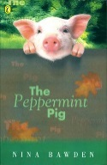](http://www.google.co.uk/url?sa=i&rct=j&q=&esrc=s&source=images&cd=&cad=rja&uact=8&ved=0ahUKEwjTpKrZ1_DNAhVlBMAKHb5BDHEQjRwIBw&url=http://www.lovereading4kids.co.uk/book/9780141368634/The-Peppermint-Pig-by-Nina-Bawden.html&bvm=bv.126993452,d.ZGg&psig=AFQjCNHIjHMLy5S1VlLj7lmBnO5BoqJs9g&ust=1468507717509210)

**Reading Comprehension Test**

At the end of Key Stage 2 (end of Year 6), your child will be required to take a SATs test to test them on their reading comprehension. Here is an example of the types of questions your child may be asked in that test.

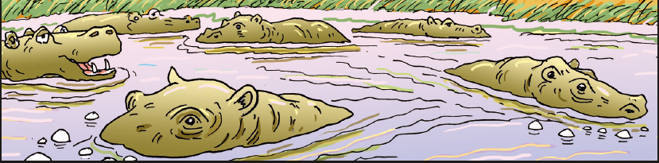

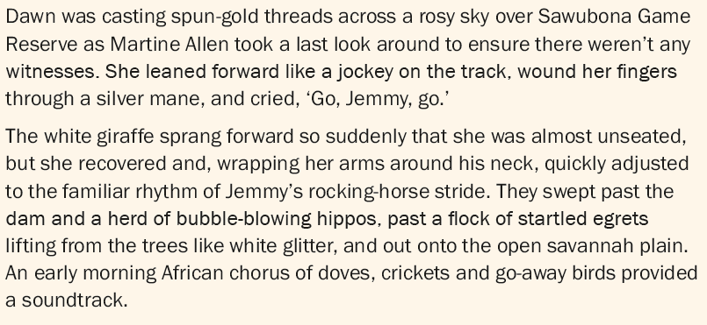

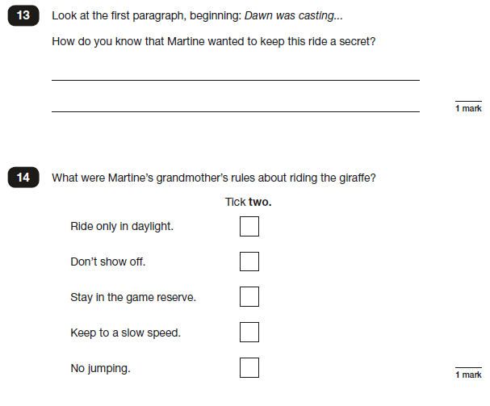

**Writing**

**By the end of Year 5, most children should be able to…**

* Have secure spelling
* Use a thesaurus
* Use legible, fluent handwriting
* Plan writing to suit an audience and purpose
* Develop character, setting and atmosphere in narrative
* Use organisational and presentational features in their writing (headings, subheadings)
* Use consistent appropriate tense
* Proof-read
* Perform own compositions

**Here are some suggestions of ways you can help your child at home:**

• Help your child write a letter to their favourite author. Correspondence can often be sent to an author’s publisher (whose details can be obtained on the internet) who will pass it on.

• When you go on holiday, encourage children to write postcards to friends or relatives. They could record things that you do in a holiday diary which they can share with friends or relatives when they get home.

• After making a cake or doing a craft activity, challenge children to write the recipe or instructions for someone else to use.

• Write an information page or booklet about something they find interesting e.g. spiders, Dr Who, dinosaurs, cats, etc. Draw a picture and label it or write a caption to go with it.

• Encourage your child to learn weekly spellings and phonic group spellings. Write the spellings in sentences with accurate punctuation and practise high frequency words and handwriting.

• Provide your child with a comfortable place to work and exciting writing materials. A dictionary and thesaurus would also be useful.

• Ask your child what his/her writing targets are from time to time and help them work specifically on these.

• Talk through their ideas with them before they start to write, for example, prompt them to think about how they intend to tackle a subject.

• Help them to reflect on their writing, particularly the effect they hoped to have on the reader. For example, is the reader sufficiently prepared for the ending? Have they introduced all the characters?

• Encourage them to read through their work, shaping their sentences for clarity and impact and checking their accuracy.

**How many of the following Year 5 and 6 words can your child spell?**



|  |  |  |  |  |  |
| --- | --- | --- | --- | --- | --- |
| **Look, Say, Cover** | **Write and check** | **Look, Say, Cover** | **Write and check** | **Look, Say, Cover** | **Write and check** |
| accommodate |  | curiosity |  | interrupt |  |
| accompany |  | definite |  | language |  |
| according |  | desperate |  | leisure |  |
| achieve |  | determined |  | lightning |  |
| aggressive |  | develop |  | marvellous |  |
| amateur |  | dictionary |  | mischievous |  |
| ancient |  | disastrous |  | muscle |  |
| apparent |  | embarrass |  | rhythm |  |
| appreciate |  | environment |  | sacrifice |  |
| attached |  | equipment |  | secretary |  |
| available |  | especially |  | shoulder |  |
| average |  | exaggerate |  | signature |  |
| awkward |  | excellent |  | sincere(ly) |  |
| bargain |  | existence |  | stomach |  |
| bruise |  | explanation |  | sufficient |  |
| category |  | familiar |  | suggest |  |
| cemetery |  | foreign |  | symbol |  |
| committee |  | forty |  | system |  |
| communicate |  | frequently |  | temperature |  |
| community |  | government |  | thorough |  |
| competition |  | guarantee |  | twelfth |  |
| conscience |  | harass |  | variety |  |
| conscious |  | hindrance |  | vegetable |  |
| controversy |  | identity |  | vehicle |  |
| convenience |  | Immediate/ly |  | yacht |  |
| correspond |  | individual |  |  |  |
| criticise |  | interfere |  |  |  |

**Handwriting at Grove Lea Primary**

We take pride in the presentation of our work. Children are taught to form their letters according to the following handwriting script:

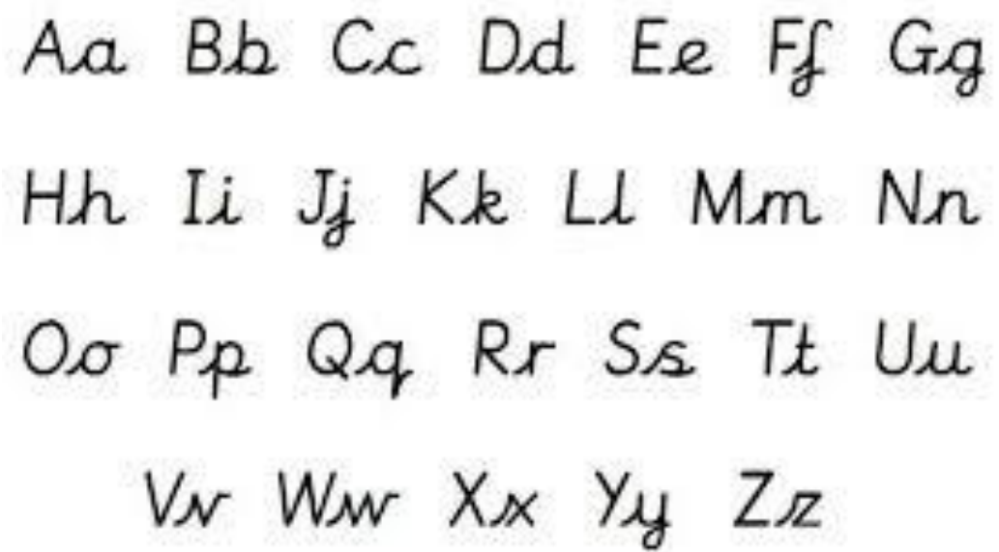

**Grammar**

**By the end of Year 5, most children should be able to…**

* Use relative clauses, beginning with who, which, where, when, whose, that, or an omitted relative pronoun
* Indicate degrees of possibility using adverbs (e.g. perhaps, surely) or modal verbs (e.g. might, should, will, must)
* Link ideas across paragraphs using adverbials of time (e.g. later, before, then), place (e.g. nearby, far away) and number (e.g. secondly, finally) or tense choices (e.g. he had seen her before)
* Use brackets, dashes or commas to indicate parenthesis (used to offset additional information in your sentence.) For example, While on holiday in London, Simon Schmidt, a fireman from New York, rescued a cat from a tree.

**Key Words:**

modal verb, relative pronoun, relative clause, parenthesis, bracket, dash, cohesion, ambiguity

**Here are some suggestions of ways you can help your child at home:**

**Poetic licence!**

Practice making /writing alliterative sentences. Who can make the longest sentence? When might we use alliteration?

Rabbit… The ravishing rabbit rowed over the river and replaced his roller boots with red rock and roll rattles. Dictionaries help here!!

**Read! Read! Read!**

Choose a quality text to share. Discuss the type of language being used and how it works within a sentence. Talk about the dialogue being used. Take parts … reading it like a play – getting into character, mood etc.

**Complete the simile…**

Practise sharing similes. Start with the most basic…as hot as…, as tall as…, the moon is like….

Now … extend the sentences – five words, six words and so on. Who can come up with the most complicated?

…as hot as the underground in July!

Keep extending…

…as slow as an old tortoise whose battery has run down…

**With your adult, add the commas to these sentences:**

**The comma - what it is and when to use it**

Lots of people get confused about using the comma. But here is one simple rule that covers all of these examples:

*Use a comma when it will make it easier for your*

*reader to understand what you are writing about.*

In other words, use a comma when, if you didn’t use one, your reader might get confused.

Is it really as simple as that? Well, let’s test it out.

1. Everyone brought flour milk eggs and sugar to class.

2. The Head teacher wants to see Jodie Jamal Tom and Nafissa.

3. Come here Hilary.

4. “Sit down here” she said.

5. Jane said “I think it's going to rain.”

6. If at first you don't succeed try try again.

7. My dog a black and white terrier is called Roxy.

8. Whitstable a small town in Kent is five miles from Canterbury.

9. Katie one of the brightest girls in the class got 100% in the test.

10. I think I’ve learned to use full stops question marks exclamation marks and commas correctly.

**I beg your pardon…what did you say?**

Re-write these sentences, putting in the speech marks and any commas, exclamation marks, question marks or capital letters that are needed in these sentences.

don't do that he shouted.

____________________________________________________

why not I asked him.

____________________________________________________

because I don't like it he replied.

____________________________________________________

tough luck I laughed.

____________________________________________________

that's not an answer he screamed

____________________________________________________

I told him don't shout like that.

____________________________________________________

he asked why not?

____________________________________________________

I replied because I don't like it.

____________________________________________________

he laughed tough luck then.

____________________________________________________

we both laughed and said enough let's go home

____________________________________________________

**All in good time…**

**Adverbs of time**… describe **when** something happens.

Here are some of the ones we often use: recently, finally, eventually, today, yesterday, tomorrow, now, soon, then, just, later, first, last, after, already, during.

Choose an **adverb of frequency** to complete each of these sentences.

1. Do it today or you will have to do it …………..…….?

2. It took us 24 hours but we ………………….... got there.

3. “When are we gonna get there?” - “……………..….**.**”

4. Clare finished the race first; her sister finished ………..……... **.**

5. Stop nagging. I’ve ……….……….… tidied my room up.

6. Andy left school early; Darren got home a little ……………… **.**

7.I’m sorry you’ve missed the head teacher. She’s ……..…… just left the building.

8. There’s been a lot of rain …..……. Even the ducks are fed up of it.

9. Don’t let the children play in the park ……………..… dark.

10. Year 5 ………..……… understood adverbs – or so they claimed.

**THE GREAT ADVERB SEARCH**

**How many adverbs can you find in this story? Underline them.**

Tom and Sally Jones had just put little Tommy to bed when suddenly they heard him crying hysterically. They rushed anxiously into the bedroom where they found five-year-old

Tommy sitting up in bed. Tears were flowing down his cheeks. This was unusual because Tommy seldom cried.

Tommy had accidentally swallowed a 5p piece and was sure he was going to die immediately. It wasn’t really serious because the 5p had gone all the way down, but no amount of explaining could change Tommy’s mind. To calm him down, Tom palmed a 5p piece from his pocket and pretended to find it behind his son’s ear.

Before he could stop him, the little lad grabbed the 5p from his dad’s hand, immediately swallowed it, and demanded cheerfully: “Do it again, Dad!” Unfortunately, for Tommy, all his dad had left in his pocket was a 50p piece!



**Grammar Punctuation and Spelling Test**

At the end of Key Stage 2 (End of Year 6), your child will be required to take a SATs test to test them on their understanding of the Grammar, Punctuation and Spelling curriculum. Here is an example of the types of questions your child may be asked in that test.

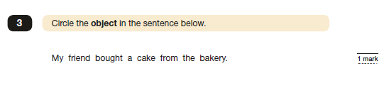

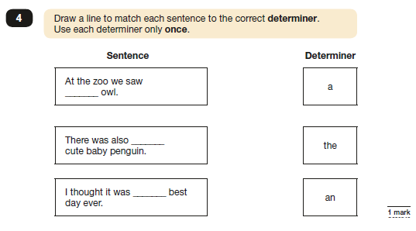

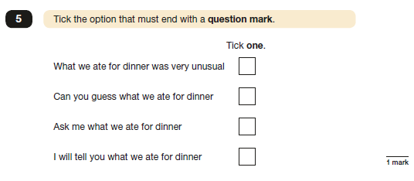

**Useful websites**

**Reading**

<http://www.everyschool.co.uk/english-key-stage-2-comprehension-2.html>

<http://www.topmarks.co.uk/english-games/7-11-years/reading>

**Writing**

<http://www.bbc.co.uk/bitesize/secondlevel/literacy_and_english/writing/leaflets_and_posters/play/popup.shtml>

**Grammar**

<http://www.bbc.co.uk/bitesize/secondlevel/literacy_and_english/writing/punctuation/play/>

<https://hwb.wales.gov.uk/cms/hwbcontent/Shared%20Documents/VTC/2012-13/flitwits/eng/literacy//ottozoom-apostrophes/index.html#/otto-zoom---apostrophes>

<https://hwb.wales.gov.uk/cms/hwbcontent/Shared%20Documents/vtc/apostrophes_possess/eng/Introduction/default.htm>

<http://www.grammar-monster.com/>

**Contact Us**

If you require any further support or guidance with supporting your child/children with English at home, please contact your child’s class teacher or the English coordinator.