Helping your child

to read and write at home

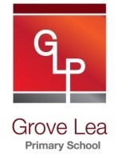

**Year 6**

Grove Lea Primary

Our Academy aims for reading are to:

* Provide a rich and stimulating reading environment.
* Enable children to read with confidence, accuracy, fluency, understanding and enjoyment.
* Foster an enthusiasm for and love of reading for life.
* To develop comprehension skills of inference and deduction.

Our school aims for writing are:

* For writing to be seen as purposeful and enjoyable.
* For writing to be seen as an essential life skill.
* For each child to develop the necessary writing skills to be a competent writer.
* For each child to see themselves as a confident and successful writer.
* For writing to be developed across a range of meaningful contexts.
* For there to be a broad curriculum offering the full spectrum of writing genres.

By the end of Year 6, children should be able to:

* Read a broad range of genres
* Recommend books to others
* Make comparisons within/across books
* Support inferences (reaching a conclusion about what they have read, using clues from the text) with evidence
* Summarising key points from texts
* Say how language and structure of a text add to meaning
* Discuss use of language, including figurative
* Discuss & explain reading, providing reasoned justifications for views

**Here are some suggestions of ways you can help your child at home:**

• Read to and with your child every day.

• Encourage your child to read a range of texts such as newspapers, comics, poetry and non-fiction.

• Discuss your child’s reading choices with them.

• Join the local library so that your child has access to an even wider range of books

• Praise your child’s efforts and encourage them to take an interest in reading in their free time.

**How many of the following Year 5 and 6 words can your child read?**

|  |  |  |  |  |  |
| --- | --- | --- | --- | --- | --- |
| accommodate |  | curiosity |  | interrupt |  |
| accompany |  | definite |  | language |  |
| according |  | desperate |  | leisure |  |
| achieve |  | determined |  | lightning |  |
| aggressive |  | develop |  | marvellous |  |
| amateur |  | dictionary |  | mischievous |  |
| ancient |  | disastrous |  | muscle |  |
| apparent |  | embarrass |  | rhythm |  |
| appreciate |  | environment |  | sacrifice |  |
| attached |  | equipment |  | secretary |  |
| available |  | especially |  | shoulder |  |
| average |  | exaggerate |  | signature |  |
| awkward |  | excellent |  | sincere(ly) |  |
| bargain |  | existence |  | stomach |  |
| bruise |  | explanation |  | sufficient |  |
| category |  | familiar |  | suggest |  |
| cemetery |  | foreign |  | symbol |  |
| committee |  | forty |  | system |  |
| communicate |  | frequently |  | temperature |  |
| community |  | government |  | thorough |  |
| competition |  | guarantee |  | twelfth |  |
| conscience |  | harass |  | variety |  |
| conscious |  | hindrance |  | vegetable |  |
| controversy |  | identity |  | vehicle |  |
| convenience |  | Immediate/ly |  | yacht |  |
| correspond |  | individual |  |  |  |
| criticise |  | interfere |  |  |  |

**Here is a list of questions that you can ask your child when reading**

* Find an unfamiliar technical word. Think about how it is used in this sentence. What do you think it means?
* How does the front cover show that this book is one in a series?
* Have you been in a similar situation to the character in this book?
* Who would you like to meet in the story? Why?
* What is the theme of this book? How does the author create a sense of loss/heroism etc.?
* Why does the author use the first person in this diary/autobiography?
* Where/when, is this story/poem set? Does this make a difference to how we read it?
* Which do you prefer; texts set in historical times or in modern times? Why?
* Can you make a list of features in this text type? Does the author use these features in the way you would expect?
* Have you read any other stories, which handle time in this way e.g. flashbacks, dreams?
* Who is this book aimed at? Do you think it is successful for this audience?
* What made you choose this book?
* Whom would you recommend this book to? Why?
* Can you find examples of simile/metaphor/alliteration/personification in this poem?
* Which words or phrases particularly stick in your mind? Why?
* What do you think is going to happen to the main character and how will they feel about this? What makes you think this?
* Why did (a character) behave in this way? Knowing what you know now, what do you think they were hoping to achieve?
* Use of language
* How does the title engage the reader?
* Give examples of words chosen by the author to describe (a character)? Are they effective?
* Can you list words and phrases which show you how the speaker is feeling?
* Can you find a descriptive phrase and consider the effect it has on the reader? Which words create this effect?
* What does... mean? Could you use a more emotive word? What about a less emotive word?
* Do the events happen in time order? If not, why not?
* Retrieve and present information from non-fiction
* What specific information do you need to retrieve from this text?
* Where would you look for information on...?
* How could you use the contents/index/glossary to help?
* Does the structure of the book help you to understand the subject?
* How is the information organised and presented? Why do you think this order/these headings were chosen?

**Reading Recommendations for Year 6**

Here at Towngate Primary Academy, we endeavour to foster a love of reading. We therefore encourage children to read for enjoyment and pleasure. Here is a list of books, which are suitable for Year 5 that will help to develop a love of reading.

|  |  |
| --- | --- |
| **Title** | **Author** |
| Carrie’s War | Nina Bawden |
| When Hitler Stole Pink Rabbit | Judith Kerr |
| Forgotten Voices of the Second World War | Max Arthur |
| The Diamond of Drury Lane | Julia Golding |
| Framed | Frank Cottrell Boyce |
| Homecoming | Cynthia Voigt |
| Noughts and Crosses | Malorie Blackman |
| Knife Edge | Malorie Blackman |
| Private Peaceful | Michael Morpurgo |
| The Secret Diary of Adrian Mole Aged 13 ¾ | Sue Townsend |
| Treasure Island | Robert Louis Stevenson |
| Mortal Engines | Philip Reeve |
| Clockwork | Philip Pullman |
| Dragon Keeper | Carole Wilkinson |
| The Curious Incident of the Dog in the Night-Time | Mark Haddon |
| Peter Pan | J M Barrie |
| Wizard of Oz | F Baum |
| Robinson Crusoe | Daniel Defoe |
| Oliver Twist | Charles Dickens |

[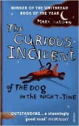](https://www.google.co.uk/url?sa=i&rct=j&q=&esrc=s&source=images&cd=&cad=rja&uact=8&ved=0ahUKEwjt8uzsnfLNAhXHJsAKHUYfAOgQjRwIBw&url=https://www.amazon.co.uk/Curious-Incident-Dog-Night-time/dp/0099450259&psig=AFQjCNEJy7IFlKoJeAzcr9KMnw8gvz1-TA&ust=1468560907809201) [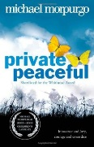](https://www.google.co.uk/url?sa=i&rct=j&q=&esrc=s&source=images&cd=&cad=rja&uact=8&ved=0ahUKEwiGiNP-nfLNAhXLIcAKHfa3CBwQjRwIBw&url=https://www.pinterest.com/PrimaryEngEd/war-and-peace/&bvm=bv.126993452,d.ZGg&psig=AFQjCNGkKOuCLScbefpAE5jj-5gpJ64Ieg&ust=1468560946759955) [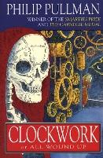](http://www.google.co.uk/url?sa=i&rct=j&q=&esrc=s&source=images&cd=&cad=rja&uact=8&ved=0ahUKEwj7vvCVnvLNAhVCDMAKHe9sBtQQjRwIBw&url=http://www.goodreads.com/book/show/24774.Clockwork&bvm=bv.126993452,d.ZGg&psig=AFQjCNFGQ90V2cExk-0KlAkgHKpcKP_vbw&ust=1468560991466022) [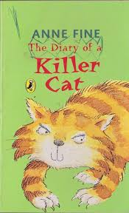](http://www.google.co.uk/url?sa=i&rct=j&q=&esrc=s&frm=1&source=images&cd=&cad=rja&uact=8&ved=0ahUKEwjsiKf9odzNAhXGC8AKHS1IBz8QjRwIBw&url=http://www.thebookshop.ie/fine-anne--the-diary-of-a-killer-cat-27505-p.asp&bvm=bv.126130881,d.ZGg&psig=AFQjCNEbYZq3g1UdkebX9AvvBkZuecrnWw&ust=1467806039946657)

[](http://www.google.co.uk/url?sa=i&rct=j&q=&esrc=s&frm=1&source=images&cd=&cad=rja&uact=8&ved=0ahUKEwjsiKf9odzNAhXGC8AKHS1IBz8QjRwIBw&url=http://www.thebookshop.ie/fine-anne--the-diary-of-a-killer-cat-27505-p.asp&bvm=bv.126130881,d.ZGg&psig=AFQjCNEbYZq3g1UdkebX9AvvBkZuecrnWw&ust=1467806039946657)

[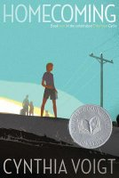](http://www.google.co.uk/url?sa=i&rct=j&q=&esrc=s&source=images&cd=&cad=rja&uact=8&ved=0ahUKEwi6xb6nnvLNAhWpKsAKHTd9BREQjRwIBw&url=http://www.goodreads.com/book/show/12125.Homecoming&bvm=bv.126993452,d.ZGg&psig=AFQjCNEO9wa-TWnKngSXZyU2XS-wgMmKIw&ust=1468561031855676)

**Reading Comprehension Test**

At the end of Key Stage 2 (end of Year 6), your child will be required to take a SATs test to test them on their reading comprehension. Here is an example of the types of questions your child may be asked in that test.

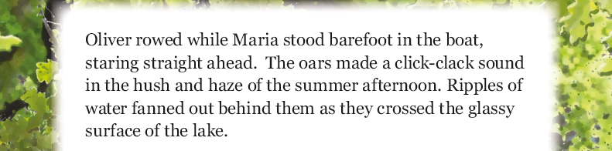

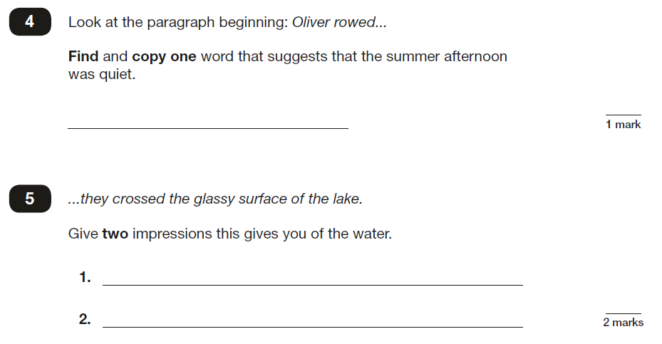

**Writing**

**By the end of Year 6, most children should be able to…**

* Use their knowledge and understanding of word structure and meaning to spell most words correctly
* Develop legible personal handwriting style
* Plan writing to suit audience and purpose
* Develop character and setting in narrative
* Select grammar and vocabulary for effect
* Use a wide range of cohesive devices to help their writing flow
* Ensure grammatical consistency

**Here are some suggestions of ways you can help your child at home:**

• Help your child write a letter to their favourite author. Correspondence can often be sent to an author’s publisher (whose details can be obtained on the internet) who will pass it on.

• When you go on holiday, encourage children to write postcards to friends or relatives. They could record things that you do in a holiday diary which they can share with friends or relatives when they get home.

• After making a cake or doing a craft activity, challenge children to write the recipe or instructions for someone else to use.

• Write an information page or booklet about something they find interesting e.g. spiders, Dr Who, dinosaurs, cats, etc. Draw a picture and label it or write a caption to go with it.

• Encourage your child to learn weekly spellings and phonic group spellings. Write the spellings in sentences with accurate punctuation and practise high frequency words and handwriting.

• Provide your child with a comfortable place to work and exciting writing materials. A dictionary and thesaurus would also be useful.

• Ask your child what his/her writing targets are from time to time and help them work specifically on these.

• Talk through their ideas with them before they start to write, for example, prompt them to think about how they intend to tackle a subject.

• Help them to reflect on their writing, particularly the effect they hoped to have on the reader. For example, is the reader sufficiently prepared for the ending? Have they introduced all the characters?

• Encourage them to read through their work, shaping their sentences for clarity and impact and checking their accuracy.

**How many of the following Year 5 and 6 words can your child spell?**

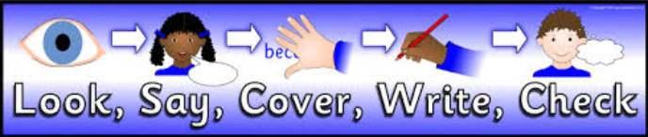

|  |  |  |  |  |  |
| --- | --- | --- | --- | --- | --- |
| **Look, Say, Cover** | **Write and check** | **Look, Say, Cover** | **Write and check** | **Look, Say, Cover** | **Write and check** |
| accommodate |  | curiosity |  | interrupt |  |
| accompany |  | definite |  | language |  |
| according |  | desperate |  | leisure |  |
| achieve |  | determined |  | lightning |  |
| aggressive |  | develop |  | marvellous |  |
| amateur |  | dictionary |  | mischievous |  |
| ancient |  | disastrous |  | muscle |  |
| apparent |  | embarrass |  | rhythm |  |
| appreciate |  | environment |  | sacrifice |  |
| attached |  | equipment |  | secretary |  |
| available |  | especially |  | shoulder |  |
| average |  | exaggerate |  | signature |  |
| awkward |  | excellent |  | sincere(ly) |  |
| bargain |  | existence |  | stomach |  |
| bruise |  | explanation |  | sufficient |  |
| category |  | familiar |  | suggest |  |
| cemetery |  | foreign |  | symbol |  |
| committee |  | forty |  | system |  |
| communicate |  | frequently |  | temperature |  |
| community |  | government |  | thorough |  |
| competition |  | guarantee |  | twelfth |  |
| conscience |  | harass |  | variety |  |
| conscious |  | hindrance |  | vegetable |  |
| controversy |  | identity |  | vehicle |  |
| convenience |  | Immediate/ly |  | yacht |  |
| correspond |  | individual |  |  |  |
| criticise |  | interfere |  |  |  |

**Handwriting at Grove Lea Primary**

At Towngate Primary Academy, we take pride in the presentation of our work. Children are taught to form their letters according to the following handwriting script:

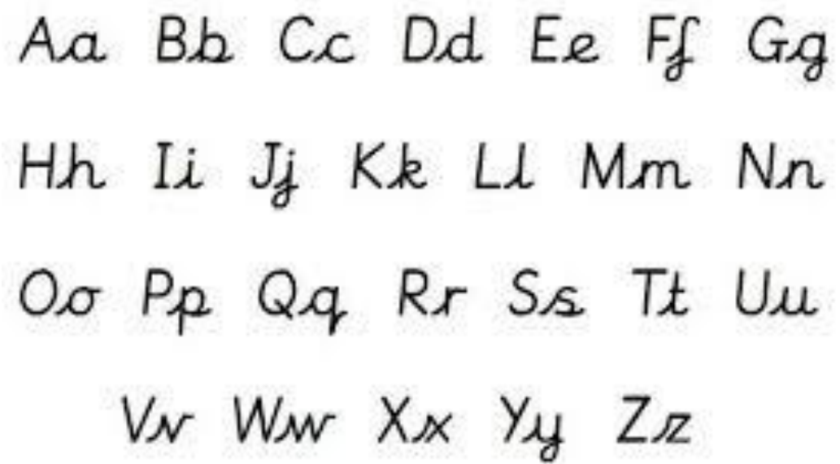

**Grammar**

**By the end of Year 6, most children should be able to…**

* Use the passive voice to affect the presentation of information in a sentence (e.g. The window in the greenhouse was broken [by me]. - instead of… I broke the window in the greenhouse.
* Know the difference between the use of informal speech or slang and that of a formal type of speech and writing (e.g. the use of question tags… He’s your friend, isn’t he?)
* Link ideas across paragraphs using a wider range of cohesive devices: repetition of a word or phrase, grammatical connections (e.g. the use of adverbials such as …on the other hand, in contrast or as a consequence), and ellipsis…
* Use layout devices (e.g. headings, subheadings, columns, bullets or tables, to structure text).
* Use the semi-colon, colon and dash to mark the boundary between independent clauses (e.g. It’s raining; I’m fed up).
* Use the colon to introduce a list and the use of semi-colons within lists.
* Use bullet points to list information.
* Use hyphens to avoid ambiguity, (e.g. man eating shark or man-eating shark, recover or re-cover)

**Key Words:**

**Words used by pupils…** subject, object, active, passive, synonym, antonym,

**Here are some suggestions of ways you can help your child at home:**

**Read! Read! Read!**

Choose a quality text to share. Discuss the type of language being used and how it works within a sentence. Talk about the dialogue being used. Take parts … reading it like a play – getting into character, mood etc.

**Crazy Clauses**

You need to put together a collection of about ten completely unconnected nouns – custard, hippo, sausage, Skegness, pimple, pencil, sunflower, photocopier, firework, slug.

Tell them that they are going to write a sentence that is going to begin with either… although, because of, after, instead of, or despite of.

At random give them two of the nouns.

Now write your sentence, make sure that it is correctly punctuated and that it makes sense…

Although the custard was hot and sweet, the hippo still managed to take a bath in it. or…

Despite of eating a large slug for breakfast, the man cycled to Skegness.

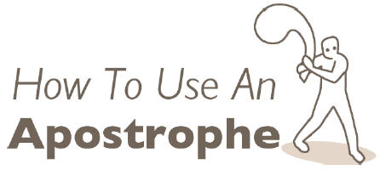

**Warning!**

Lots of people who should know better stick in an apostrophe every whenever they see the letter s at the end of a word. That’s wrong! You can see examples of this all over your local High Street. Please help us stamp out Apostrophe Abuse!

**Contractions…**

Read this with a parent and use an apostrophe to leave out a letter or letter where you can in some of the words.

*If you do not understand something, it is always best to ask for help. What would you do if you broke a finger? You would go to the doctor. He would treat the finger. He would give you good advice. If you did not listen to the doctor, you would be very silly. It is the same in school. We are here to learn things. So when we do not understand something, we should ask for help. That makes sense, does it not?*

**All in good time…**

**Adverbs of time**… describe **when** something happens.

Here are some of the ones we often use: recently, finally, eventually, today, yesterday, tomorrow, now, soon, then, just, later, first, last, after, already, during.

Choose an **adverb of frequency** to complete each of these sentences.

1. Do it today or you will have to do it …………..…….?

2. It took us 24 hours but we ………………….... got there.

3. “When are we gonna get there?” - “……………..….**.**”

4. Clare finished the race first; her sister finished ………..……... **.**

5. Stop nagging. I’ve ……….……….… tidied my room up.

6. Andy left school early; Darren got home a little ……………… **.**

7.I’m sorry you’ve missed the head teacher. She’s ……..…… just left the building.

8. There’s been a lot of rain …..……. Even the ducks are fed up of it.

9. Don’t let the children play in the park ……………..… dark.

10. Year 5 ………..……… understood adverbs – or so they claimed.

**Possessive apostrophes**

We also use an apostrophe to show that something belongs to someone or to something. In other words, they possess it, so we call it the **possessive apostrophe**.

Put the apostrophes in the correct place in each sentence.

1) Heres that boys pencil.

2) Thats my mothers best friend.

3) Both cars bumpers got dented.

4) Sallys jacket needs mending.

5) The birds wing is broken.

6) The childrens minibus has arrived.

7) Why is Davids sister crying?

8) The mices tails were cut off.

9) Jamess answer is correct.

10) Who took the boys bicycles?

11) This books last page is missing.

12) The ladies room is over there.

**THE GREAT ADVERB SEARCH**

**How many adverbs can you find in this story? Underline them.**

Tom and Sally Jones had just put little Tommy to bed when suddenly they heard him crying hysterically. They rushed anxiously into the bedroom where they found five-year-old

Tommy sitting up in bed. Tears were flowing down his cheeks. This was unusual because Tommy seldom cried.

Tommy had accidentally swallowed a 5p piece and was sure he was going to die immediately. It wasn’t really serious because the 5p had gone all the way down, but no amount of explaining could change Tommy’s mind. To calm him down, Tom palmed a 5p piece from his pocket and pretended to find it behind his son’s ear.

Before he could stop him, the little lad grabbed the 5p from his dad’s hand, immediately swallowed it, and demanded cheerfully: “Do it again, Dad!” Unfortunately for Tommy, all his dad had left in his pocket was a 50p piece!



**Semi colon - things to note**

* the semi-colon separates two complete sentences;
* the second sentence has a strong relation to the first sentence;
* the semi-colon can be used **in the place** of a conjunction;
* do **not** use a capital letter after a semi-colon unless it would have one anyway; for example ‘I’ or a proper noun such as a name.

**Add semi-colons where appropriate and explain why they are there.**

1. We missed the last bus we had to walk all the way home.

________________________________________________________2. Dogs are pack animals cats are solitary creatures.

________________________________________________________3. Gabe has taken up the guitar I pity his poor neighbours.

________________________________________________________4. A smile is the shortest distance between friends smile a lot.

________________________________________________________5. Girls are from Venus boys are from Mars that’s a scientific fact.

________________________________________________________6. Amber wore a white dress for the wedding Archie wore his kilt.

________________________________________________________7. You said robbing the bank would be easy why are we in prison then?

________________________________________________________

**Warning!**

Some students are so thrilled by semi-colons that they splatter them all over their writing. Do not do this. Use only two or three in any piece of writing. If you use too many, it just looks silly – and you’ll probably get them wrong.

**Grammar Punctuation and Spelling Test**

At the end of Key Stage 2 (End of Year 6), your child will be required to take a SATs test to test them on their understanding of the Grammar, Punctuation and Spelling curriculum. Here is an example of the types of questions your child may be asked in that test.

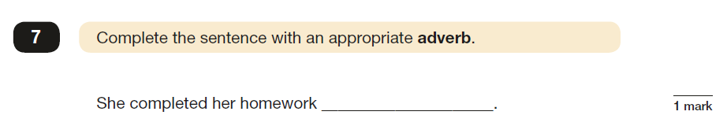

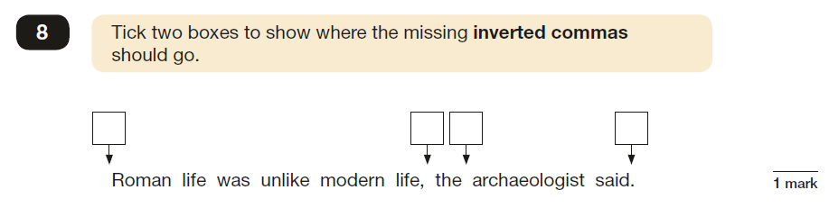

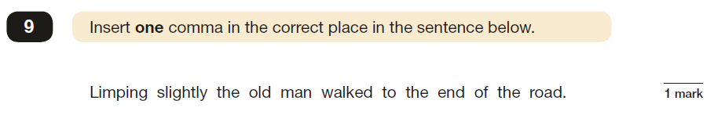

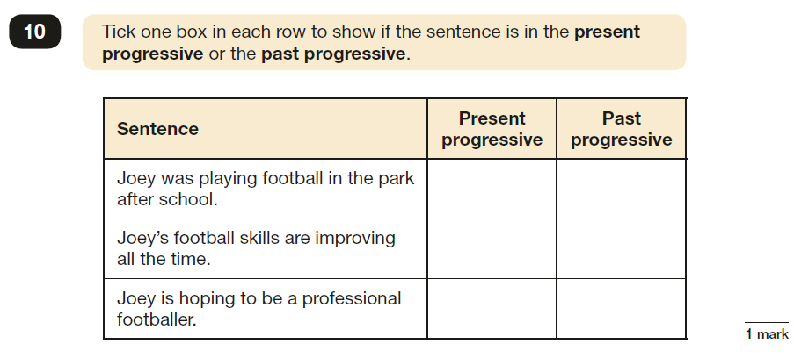

**Useful websites**

**Reading**

<http://www.everyschool.co.uk/english-key-stage-2-comprehension-2.html>

<http://www.topmarks.co.uk/english-games/7-11-years/reading>

**Writing**

<http://www.bbc.co.uk/bitesize/secondlevel/literacy_and_english/writing/leaflets_and_posters/play/popup.shtml>

**Grammar**

<http://www.bbc.co.uk/bitesize/secondlevel/literacy_and_english/writing/punctuation/play/>

<https://hwb.wales.gov.uk/cms/hwbcontent/Shared%20Documents/VTC/2012-13/flitwits/eng/literacy//ottozoom-apostrophes/index.html#/otto-zoom---apostrophes>

<https://hwb.wales.gov.uk/cms/hwbcontent/Shared%20Documents/vtc/apostrophes_possess/eng/Introduction/default.htm>

<http://www.grammar-monster.com/>



**Grammar Punctuation and Spelling Test**

At the end of Key Stage 2 (End of Year 6), your child will be required to take a SATs test to test them on their understanding of the Grammar, Punctuation and Spelling curriculum. Here is an example of the types of questions your child may be asked in that test.

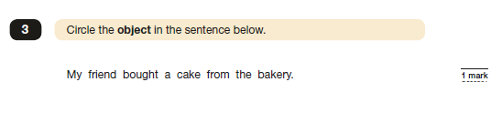

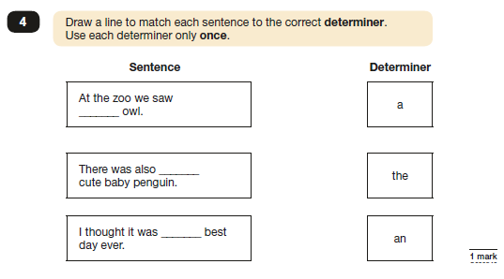

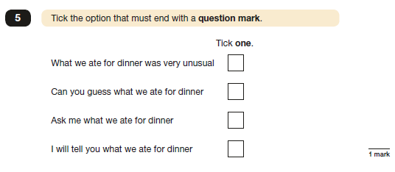

**Useful websites**

**Reading**

<http://www.everyschool.co.uk/english-key-stage-2-comprehension-2.html>

<http://www.topmarks.co.uk/english-games/7-11-years/reading>

**Writing**

<http://www.bbc.co.uk/bitesize/secondlevel/literacy_and_english/writing/leaflets_and_posters/play/popup.shtml>

**Grammar**

<http://www.bbc.co.uk/bitesize/secondlevel/literacy_and_english/writing/punctuation/play/>

<https://hwb.wales.gov.uk/cms/hwbcontent/Shared%20Documents/VTC/2012-13/flitwits/eng/literacy//ottozoom-apostrophes/index.html#/otto-zoom---apostrophes>

<https://hwb.wales.gov.uk/cms/hwbcontent/Shared%20Documents/vtc/apostrophes_possess/eng/Introduction/default.htm>

<http://www.grammar-monster.com/>

**Contact Us**

If you require any further support or guidance with supporting your child/children with English at home, please contact your child’s class teacher or the English coordinator.